Data Analysis for Mobile Action i-gotU GPS units and Lotek 3300 GPS tracking collars.

By:

Colt W. Knight, PhD – University of Maine

Derek Bailey, PhD – New Mexico State University

Version 1

1/23/2017

Table of Contents

Chapter 1 – Creating a low-cost GPS collars utilizing Mobile Action i-gotU GT-120 travel and sports loggers and traditional leather working tools.

4

Making GPS Tracking Collars for Cattle 4

Making the GPS Unit 8

Table 5. Knight GPS tracking collar materials and cost estimate based on fabrication of thirty collars

10

Figure 2. Buckle end measurements 11

Figure 3. Adjustment hole end 11

Figure 4. Picture of assembled buckle end 11

Figure 5. Blueprint of GPS pouch 12

Chapter 2 - Setting up Mobile Action i-gotU 120 travel and sports loggers for data collection and extracting data

13

Utilizing @trip PC to look at individual animal data 17

Configuring Mobile Action i-gotU GT120 travel and sports logger 21

Chapter 3 – Sorting bad data from Mobile Action i-gotU GT120 travel and sports loggers

25

Chapter 4 – Converting Longitude and Latitude to UTM (Northing and Easting)

36

Chapter 5 – Estimating Distance traveled

38

Chapter 6 – Generating Accurate Elevation measurements

49

Chapter 7 – Generating Slope utilization data

51

Chapter 8 – Generating Distance from Water measurements

55

Chapter 9 – Utilize Pivot Tables in Excel to easily calculate Means, Mins, Max, and Counts.

60

*Chapter 10 – Acquiring/Generating pasture border shape files for ArcMap*

*Incomplete*

*Chapter 11 – Correcting i-gotU Distance Traveled Data Based on Fix Rate and Fix Interval*

*Incomplete*

*Chapter 12 – Possibilities for Other Analyses*

*???*

**Chapter 1 – Creating a low-cost GPS collars utilizing Mobile Action igot-U 120 travel and sports loggers and traditional leather working tools.**

**MAKING THE COLLAR FOR CATTLE**

1. Place heavy latigo leather side on large table (table top will be cut/scratched)

2. Using a long straight edge (1.2-1.8 m (4-6 feet) aluminum rulers available at the hardware store work well), trim the back side of the leather straight using a sharp utility knife (change blades frequently when working with leather).

3. Place the newly cut straight edge of the leather side along the edge of the table. Supporting the leather with one hand, use a draw gauge set to 38.1 mm (1.5 inch) to cut straps the length of the leather.

1. *NOTE - Avoid using the belly portion of the latigo side. It is soft and will not stay stiff over time.*

4. Cut straps to 1346 mm (53 inches).

5. Use a 1346 mm (1.5 inches) English point strap end cutter to shape both ends of the strap.

6. Using card stock or manila folder material create templates for the buckle end of the strap and the adjustment hole end of the strap. Punch holes in appropriate locations.

*a. See Figure 2. Buckle end measurements*

*b. See Figure 3. Adjustment hole end*

7. Place template on appropriate end of the strap, and use a large black permanent marker to mark all punch locations.

8. Using a quality 3.175mm (0.125 inches) leather hole punch and leather working maul lubricate end of the punch using a block of beeswax and punch holes in buckle end of the strap. Using a quality 25.4 mm (1 inch) oblong punch, lubricate the punch in a block of beeswax and punch 1in oblong hole in the buckle end of the strap. See Figure 2

*a. NOTE – Use a quality punch that you strike with a hammer (Weaver Leather in Mt. Hope, OH supplies Weaver Master Tools). Plier type punches will take longer to use and most likely break before all collars are made.*

*b. NOTE – Not using beeswax will cause the punches to become stuck in the leather. The beeswax will lubricate the tool end and make removing punches much easier.*

*c. NOTE – Do not strike leather working tools with a metal hammer, only use rawhide or poly head mallets and mauls.*

*d. NOTE – Mauls are rounded to prevent pitting with repeated striking. Mallets have flat faces. Mauls will have an extended service life but mallets will be easier to strike punches. Heavier Mauls and Mallets make hole punching in thick leather easier because the weight of the tool does the work.*

*e. NOTE – Thick latigo leather can be bent over easily if it is soaked in water and placed in a bench vice. This makes installing the rivets much easier because the strap sits flush.*

9. Starting six inches from the opposite end of the strap from the buckle end, begin punching 6.35 mm (0.25 inch) holes 31.75 mm (1.25 inch) apart. 9 holes total. See Figure 3.

*a. NOTE – Punching holes is much easier if you have a solid workbench and a good polymer pad or tree stump to prevent damage to the end of the punch or making the punch dull prematurely*

*b. NOTE – Punches can be kept sharp by frequently lubricating with beeswax (stabbing the punch into the beeswax block lightly is enough). Also, punches can be kept very sharp by stropping the punch along a piece of leather with automotive rubbing compound or jewelers rouge.*

10. Place a 1346 mm (1.5 inches) stainless steel center bar buckle on the buckle end of the strap.

11. Using 15.875mm (0.625 inch) #12 copper rivets and a #12 copper rivet setter, rivet first two position rivets to hold buckle onto strap.

1. *NOTE – To use copper rivets, place rivet through both holes, and place on a solid metal surface such as an anvil or shop vice. Place bur on top of rivet, and drive bur to the leather with a single firm blow from the maul and rivet setter. Once bur is in place, use a set of heavy nipper (like horse shoeing nippers – Authors use 406 mm (16 inches) Channel Lock nippers available from hardware stores) to remove excess rivet shaft (about 15.875mm (0.0625 inch) from the bur). Then use the rounded portion of the rivet setter to peen the rivet head. This will take 2-3 blows from the maul.*

12. Place a 1346 mm (1.5 inches) stainless steel keeper between the 2nd and 3rd holes, and install 3rd copper rivet See Figure 4

13. Create a template for GPS pouch. See Figure 5

14. Trace templates onto 8 oz vegetable tanned leather and cut/punch.

*a. NOTE – vegetable tanned leather is also referred to as tooling leather, skirting leather, saddle leather or strap sides. It is available in many different forms from many different tanneries. Purchasing a side or 2 double shoulders should be enough to construct 30 collars.*

*b. Lining up straight edges on the leather hide will allow you to cut the leather with a long straight edge and a sharp utility knife – change blades often.*

*c. NOTE – Do not cut 90° concave corners in leather – It creates a weak point that can tear easily. Instead, use a hole punch in the corners. This also prevents accidently cutting into the pouch with the utility knife. This also makes cutting the straight edges with the utility knife easier. Authors prefer to use a 9.5 mm (0.375 inch) punch to allow a lot of room for the utility knife blade.*

15. Approximately 508 mm (20 inches) from the buckle end of the strap, rivet the wide portion of the pouch to the strap using 2 #12 copper rivets using the holes located between the stitch lines on figure 5.

16. Stitch the pouch to the leather strap using a Compound Feed walking foot sewing machine using at least #138 bonded nylon thread. The first 3 and last 3 stitches need to be back stitched, and thread ends melted with a lighter to secure in place.

*a. NOTE- Bigger thread like # 207 or #277 would be better, but stitch size is dependent on sewing machine.*

*b. NOTE – compound feed walking foot sewing machines are expensive (starting ~ $1600), and used machines can be hard to find. This may need to be an outsourced step. Hand sewing is possible using pricking irons and harness needles using a saddle stitch but probably too labor intensive to be practical. Authors use a modified Consew 206RB-1 to stitch collars. Generic copies of JUKI 441 machines would work best for this task (makers Cobra, Cowboy, Techsew, etc.)*

17. Place Corner F and Corner A together and stitch the entire edge 4.76 mm (0.1875 inch) or 6.35 mm (0.25 inch) from the edge. Again, backstitching the first and last 3 stitches. Melt the thread ends.

18. Repeat, but place Corners H and C together and stich the length of the edge.

1. *NOTE – Edges will not align perfectly. Once both edges are sewn, place them on the edge of a table and use a sharp utility knife to cut the edge flush.*

19. Close the flap using 9.5 mm (0.375 inch) decorative Chicago screws.

a*. NOTE – Place the decorative head of the screw inside the pouch. The decorative head provides grip from the rough surface and make tightening the screw easier.*

*b. NOTE – Chicago screws will come loose eventually – Authors use Loc Tite to hold screws together permanently. To remove the GPS Unit, simply cut the Chicago screw with the nippers.*

20. Strap is now ready to be used with GPS unit.

a*. If you would like to attach a permanent number to the collar, Authors recommend buying set of number stamps. Soak the leather with water, place on a hard solid surface, and stamp the numbers into the leather using the stamp and maul. Custom makers mark stamps can be purchased to add identifying marks if desired.*

**MAKING THE GPS UNIT**

1. Remove rubber cover from i-gotU GT-120 GPS Unit (GPS).

2. Punch a 3.2 mm (0.125 inch) hole in the back right corner (on the side close to the back) of the rubber cover.

3. Place batter leads through the rubber cover hole just punched (from outside in).

4. Tin the leads of the 3.7volt 5200miliamphour li-ion battery pack.

*a. NOTE -Tinning is melting solder to the ends of the wire. Heat the wire not the solder with the solder iron and touch the solder to the hot wire to melt it into the strands of the wire. Heating the solder will result in cold solder joints that will fail at a later date. Do not blow on hot solder it creates weak/brittle solder joint.*

*b. NOTE – Make sure the battery pack has PCB protection (overcharge protection).*

5. On the back right corner of the GPS, careful pry the back cover off using an awl. Don’t worry about slightly damaging the side wall at the entry point. This will also serve as a location to file a small notch for the battery leads.

*a. NOTE – This unit is not made to come apart. Care needs to be taken not to damage the portion of the case with the USB plug port.*

*b. NOTE – The silicone board located in the GPS unit can be damaged if the board is allowed to pivot up and down. Be careful, and don’t let it rock up and down.*

6. Remove battery from back. Apply light pressure to existing battery leads. Touch soldering iron to solder holding battery leads to the unit. Remove one at a time.

7. Solder new battery pack leads onto the unit. If you forget which wire goes where, the Red wire attaches to the positive side, which is marked with a (+).

1. *NOTE – stray solder or solder pooling together can be corrected by scraping it with the awl. If care is taken, no damage will be done.*

8. Apply liquid electrical tape to the circuit board. Cutting an appropriate sized hole in cardboard makes a great spraying template. Allow to dry thoroughly.

1. *NOTE – Use liquid tape conservatively. Applying to heavily will allow liquid tape to bleed around the circuit board and block the LED lights. The LED lights are extremely useful in telling whether the unit is on and acquiring signal.*

9. Mix two-part marine epoxy and apply a small amount to secure battery leads to circuit board. Then apply a small amount to the circuit board. Do not cover GPS antenna with epoxy (metallic square located on the opposite side of the circuit board from the USB cable connection).

10. While epoxy is still wet, make a small loop in the battery leads and mash it into the epoxy. Place more epoxy on top of the loop and replace the back cover. Use electrical tape to hold the unit together while it dries. Take care not to cover up the 2 LED lights or USB port. Making the loop on the inside of the unit and epoxying it in place prevents the wires from being pulled out or applying any pressure to the circuit board.

1. *NOTE – Epoxying the board you can easily rock the circuit board and break the connections rendering the unit useless. Take extra care on this step. Once the epoxy has set though, the unit is extremely tough. Authors suggest buying 3-4 extra GPS units in case you break a few. Also, due to the nature of inexpensive electronics, you may find a malfunctioning unit. Having a few spares on hand is nice.*

11. Leave on electrical tape and replace rubber case.

12. Place in a quality 0.95 liter (1 quart) freezer bag. Remove air, zip closed.

13. Place decorative end of Chicago screw on the inside of pouch.

14. Place bagged gps in Batter first and unit button facing down (towards the latigo strap) to prevent anything from accidently poking the top and pushing the button.

1*5. * Authors like to put two bands of gorilla tape around the pouch to add a third means of attachment*

*16. The tail of the strap, once on the animal, is secured using gorilla tape. Also, placing a hole on the tail end of the strap for an outdoor rated cable tie provides extra security.*

*The i-gotU GT-120 will store 65,000 way points, and the above battery pack will last at least 6 months set to take reading every 10 min. Authors have not yet run the units longer than 6 months.*

*The unit may need to be reset after installing the new battery. Simply connect the unit to a computer with the included USB cable to allow it to reboot.*

**Table 5.** Knight GPS tracking collar materials and cost estimate based on fabrication of 30 collars

*Quantity Material Cost per unit*

(2) 12/13 oz. Latigo leather side 225.00

(1) 4’ Straight edge 16.38

(1) Utility knife 6.38

(1) Package utility knife blades 18.50

(1) Leather working draw gauge 36.25

(1) English point strap end cutter 73.00

(1) Card stock/manila folder 0.00

(1) 1/8” Hole punch 35.25

(1) 1” Oblong hole punch 86.00

(1) 1/4” hole punch 36.00

(1) Leather working maul/mallet 95.00

(1) High density polyethylene cutting board 8.96

(1) Bees wax block 4.98

(30) Stainless steel center bar buckle 1.5” 3.50

(1) 10” Channel Lock nippers 22.64

(1) 1 lb #12 0.625” copper rivets and burs 27.00

(1) #12 copper rivet setter 18.80

(30) 1.5” stainless steel keepers 0.40

(1) 8 oz vegtan leather side 102.00

(1) 3/8” leather hole punch 41.50

(34) Mobile Action i-gotU GT-120 GPS data logger 50.00

(30) Tenergy Li-Ion 18650 3.7V 5200mAh PCB Protected 19.99

(1) Soldering iron with pencil tip 12.99

(1) Solder – 0.022 rosin core solder 7.99

(1) Awl 4.38

(4) Two-part marine grade epoxy 5.77

(1) Roll of electrical tape 1.99

(1) Small round file 3.98

(1) Liquid electrical tape 7.47

(1) Loc tite 6.48

(5) 1” Gorilla® tape 2.98

(1) 3/8” Chicago Screws (100 count box) 26.25

(1) Cowboy 3200 sewing machine 1800.00

**Total $ 5404.67**

**Cost per collar (N = 30) $ 180.16**

*Cost reflect US dollars. Prices do not reflect quantity or wholesale discounts. Hide House, Napa, California – Resource for leather. Weaver Leather Supply, Mount Hope, Ohio – Leather tools and hardware. Toledo Industrial Sewing Supply, Toledo, Ohio – Sewing machine. Remaining items are commonly available from hardware store or online retailers such as Amazon.com*

**Figure 2.** Buckle end measurements

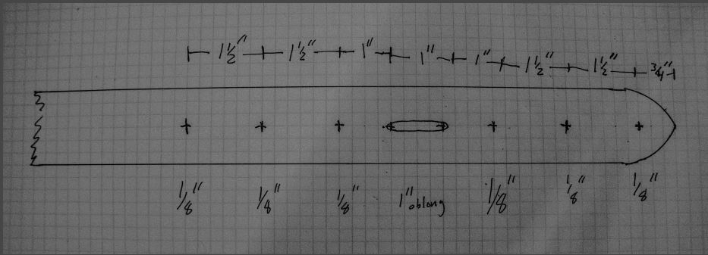

*Resolution of squares equals 0.25 in*

**Figure 3.** Adjustment hole end

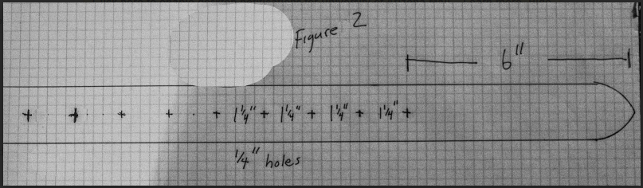

*Resolution of squares equals 0.25 in*

**Figure 4.** Picture of assembled buckle end

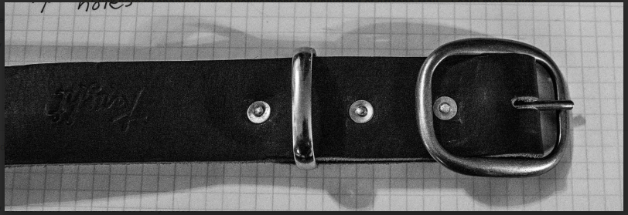

*Resolution of squares equals 0.25 in*

**Figure 5.** Blueprint of GPS pouch

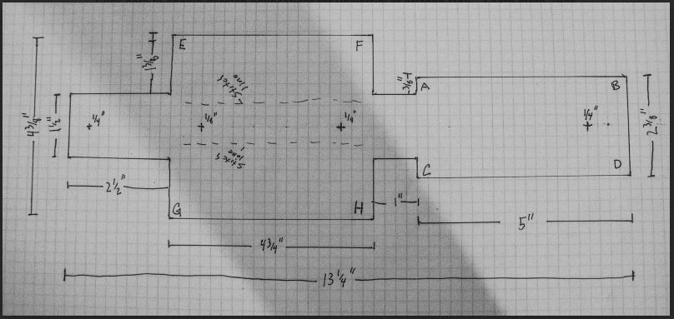

*Resolution of squares equals 0.25 in*

**Chapter 2 - Setting up Mobile Action i-gotU 120 travel and sports loggers for data collection**

Step 1. Download the Mobile Action igot-U software @TRIP PC (97 MB) from

<http://global.mobileaction.com/download/i-gotU_download1.jsp>

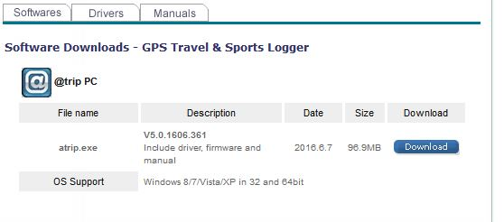

Step 2. Install the Travel & Sport Suite software (Typical)

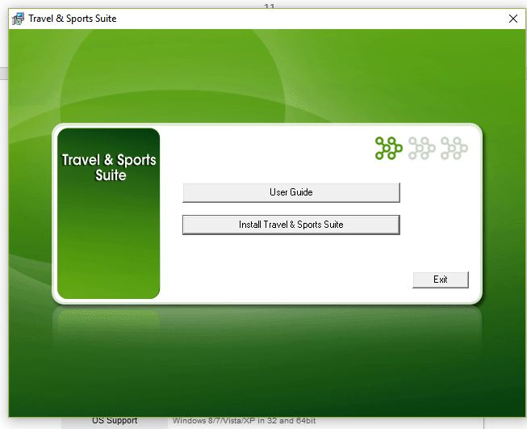

Step 3. Create the following folder on your C drive :

C:\GT_DATA_LOG

Step 4. Open the software by clicking on the @Trip PC icon



The home screen will look like this

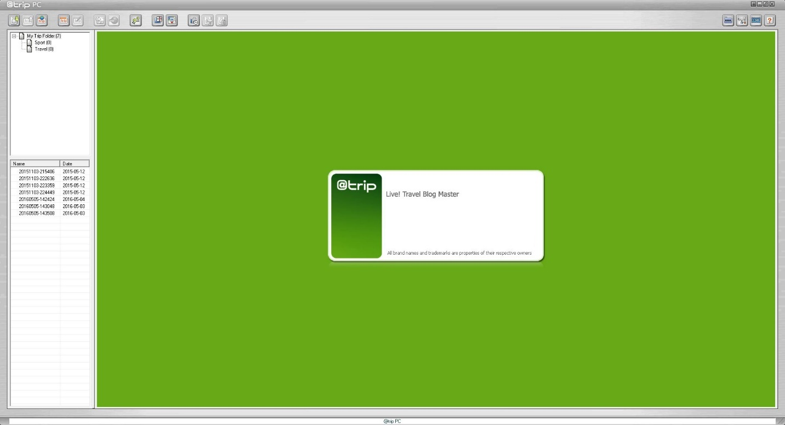

Step 5. Plug the included USB cord into the computer and attach the i-gotU GPS device. You will be prompted with the following pop up box to log GPS data, click YES.

*Note – the metal connection pins on the device can build up a level of corrosion when left on range for extended period of time and this will cause a poor connection. Take a pocket knife or fine sandpaper and clean the connections if the computer fails to recognize the device.*

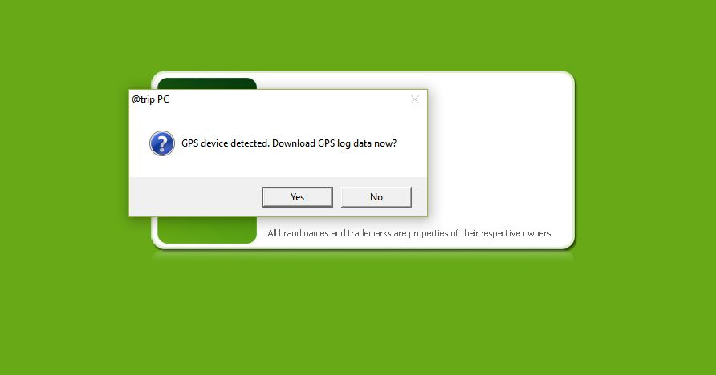

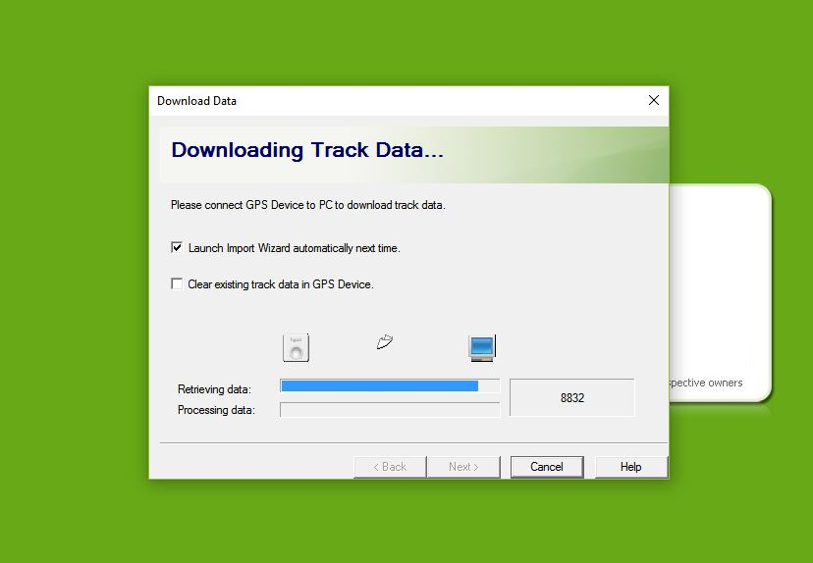

Data is now saved as a .csv file in

C:\GT_DATA_LOG

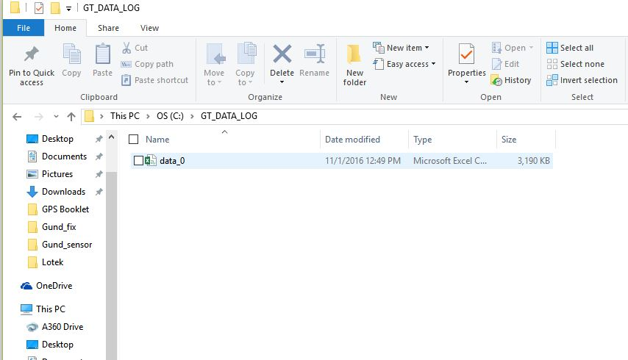

Rename the file – Processing GPS data creates a lot of folders and files. Take this opportunity to begin storing information in an organized fashion.

I suggest naming the file by (Location_timeperiod_collarnumber_animalID) for example, this example is from a research study at the University of Arizona’s V-bar-V ranch in 2015 from GPS collar #17 placed on cow 5209. ArcMap (a program to be used later for further data processing) does not like spaces or exceptionally long file names, so use underscores.

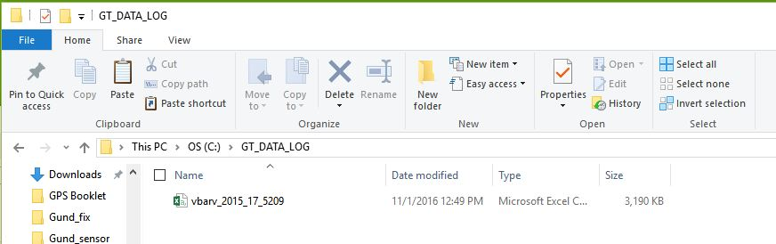

Once you have downloaded data from all collars and renamed the files, move them to a new folder location.

***(Optional)***

Utilizing @trip PC to look at individual animal data

Plug the included USB cord into the computer and attach the i-gotU GPS device. You will be prompted with the following pop up box to log GPS data, click YES. When you are prompted to create a trip, select “Create a trip” and click Next>

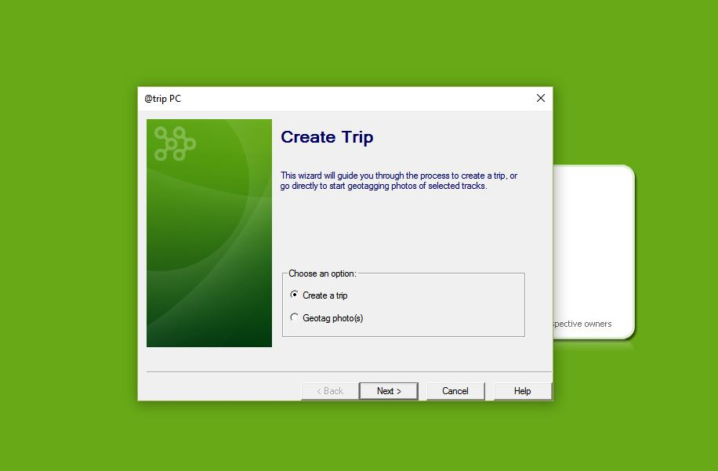

The following screen will appear. Do not click or de highlight any selected data, simply press Next>

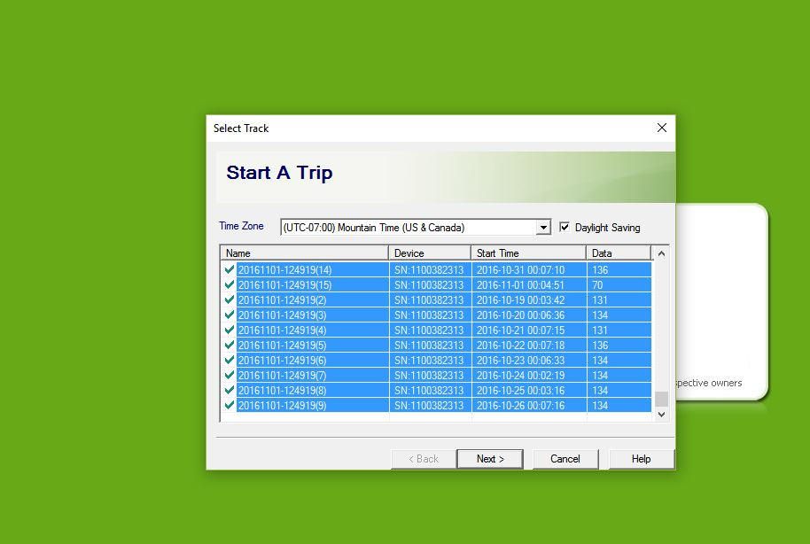

The following screen will appear. Rename the trip to easily identify it later. Once you download more than one trip, the number ID generated by the program will easily be confused the following trips.

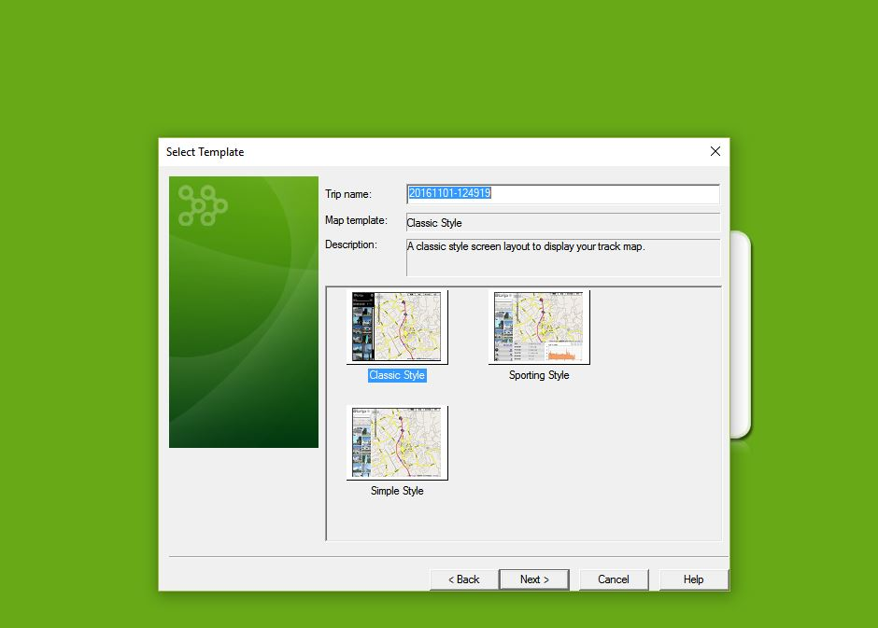

Select which ever template style you prefer. I generally utilize classic style. Sporting style will show extra information such as elevation and speed.

The following screen will appear. Select the appropriate time zone and click Next> following by Finish

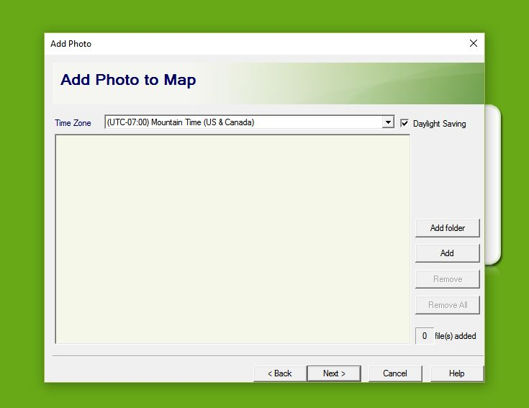

You can now view your trip on Google Maps.

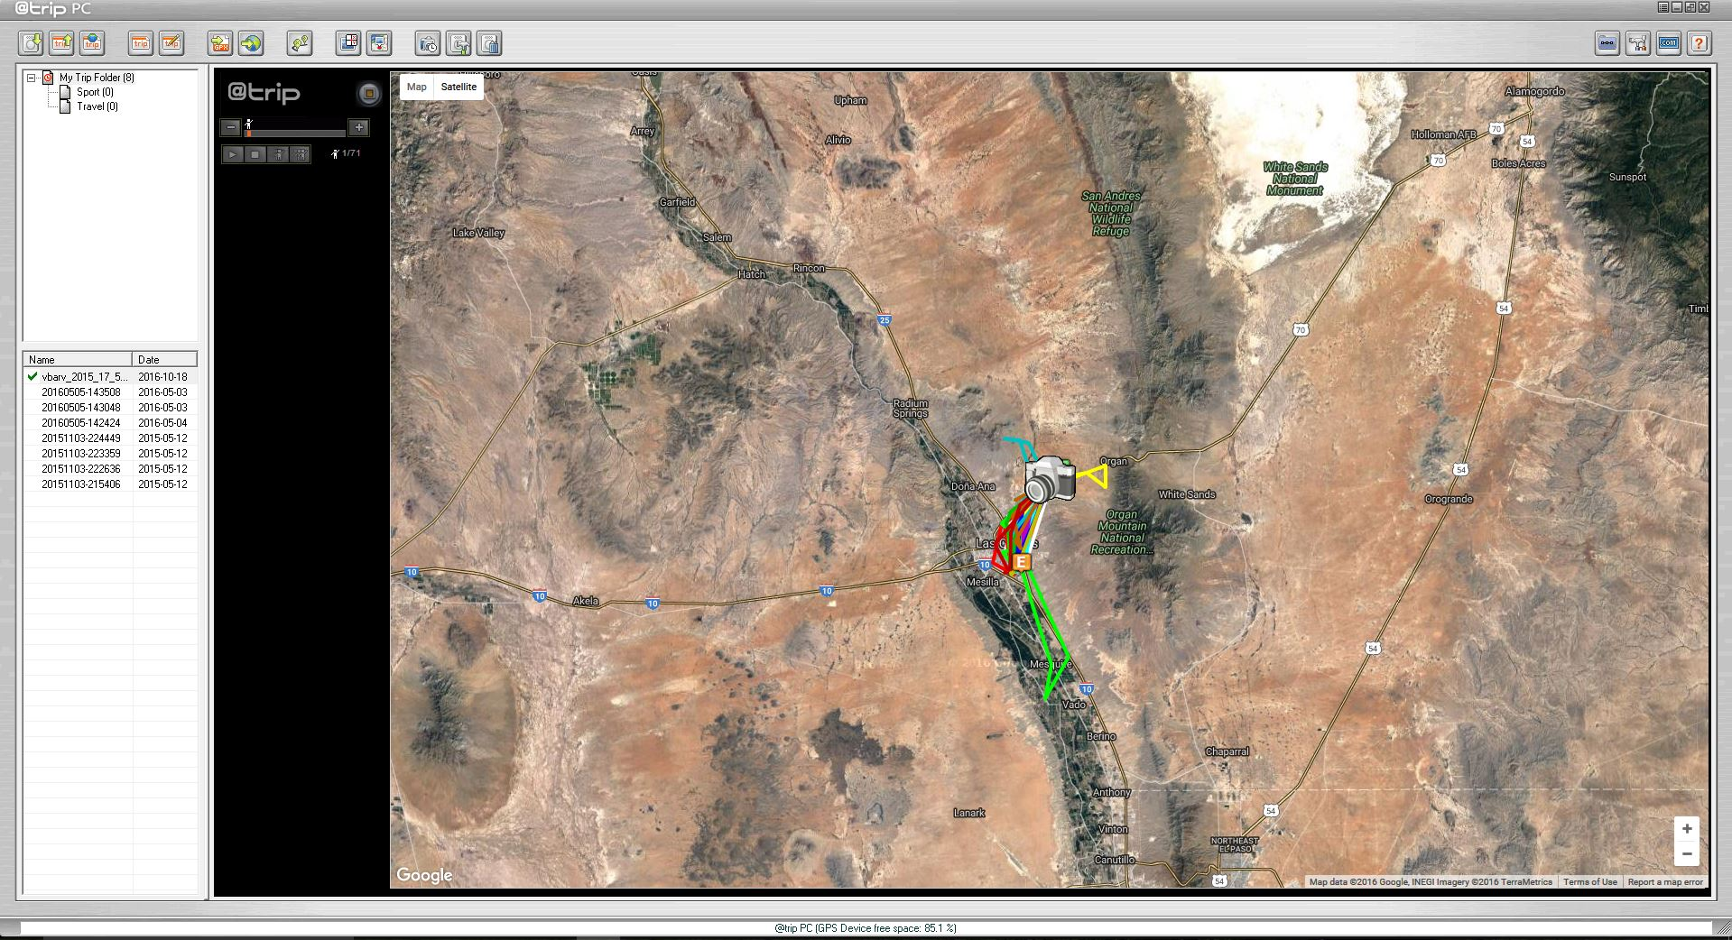

Or Google Earth by clicking the following button



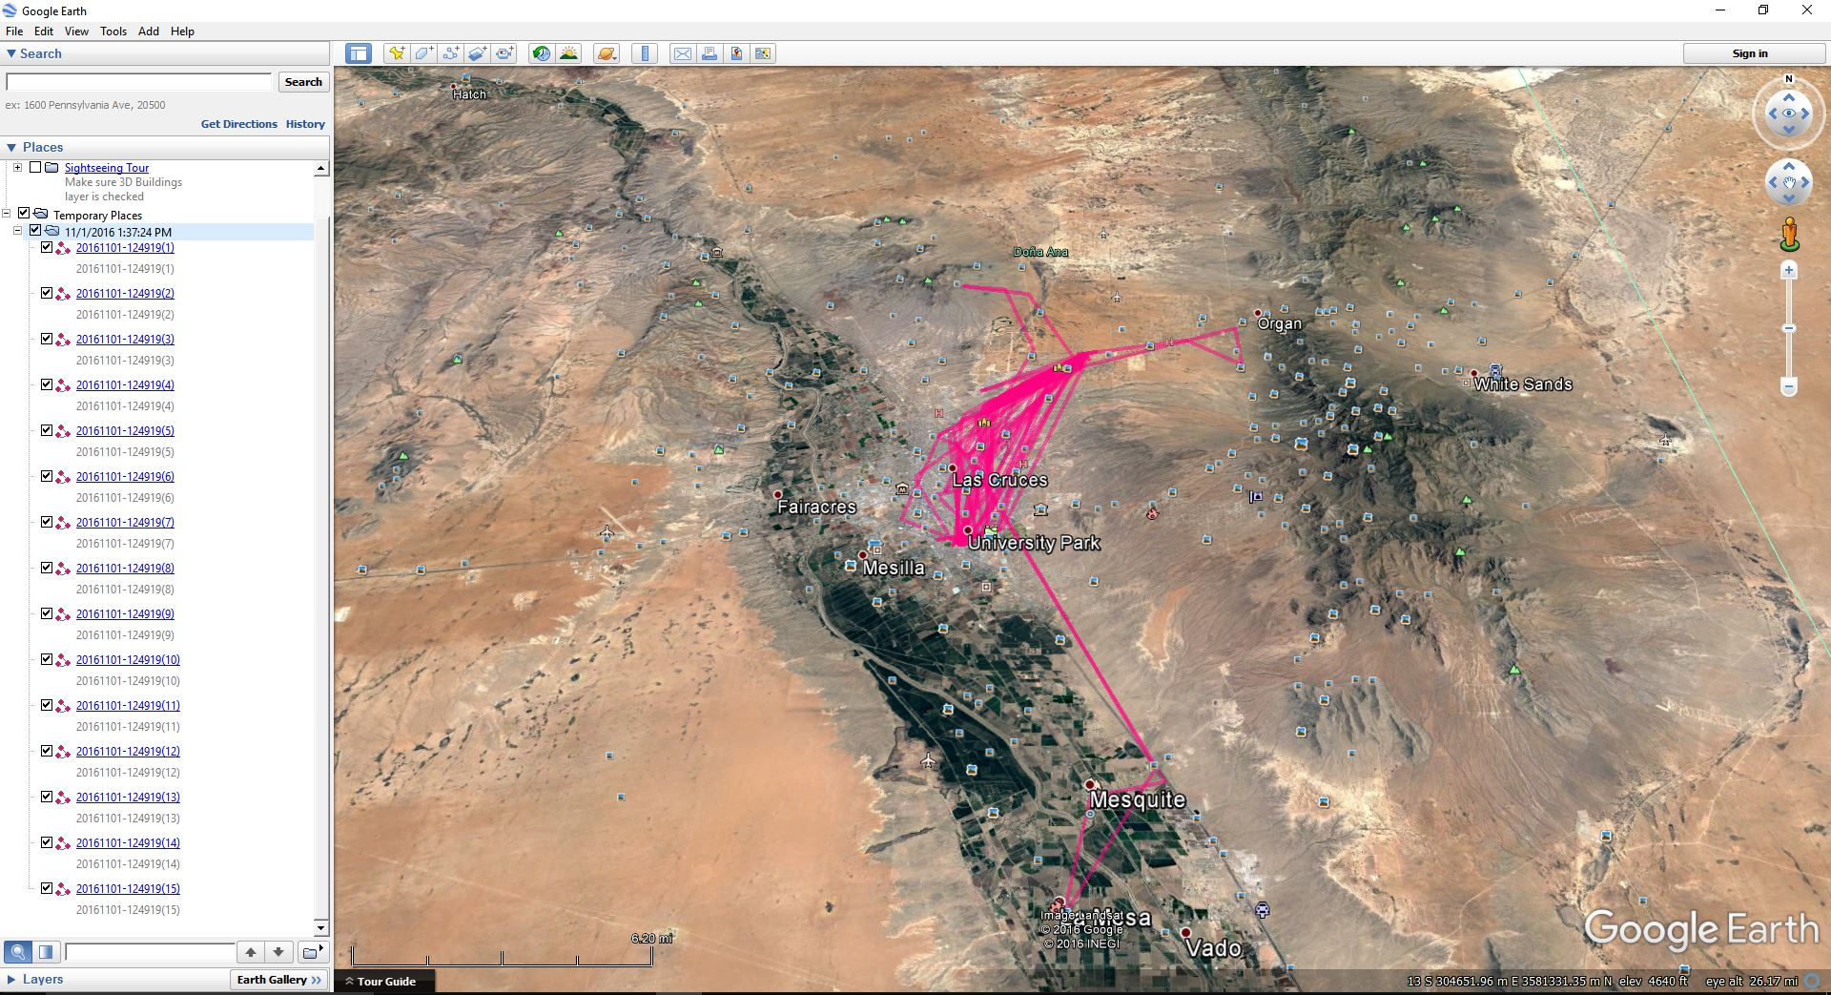

To save the GPS data from @trip PC, right click the file name on the left side of the screen, and select Export to CSV. Please note, you only get the basic tracking data using this method, and you will not get any satellite or error information like the data set saved in C:\GT_DATA_LOG, and this data cannot be recovered unless the file is saved from the device to folder C:\GT_DATA_LOG

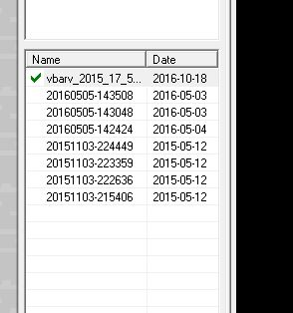

Data can be deleted using this button



The GPS unit can be reconfigured or Setup using the following button

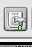

Screen 1 – Use this screen if you wish to setup password protection or Reset settings. Click Next to advance to screen 2

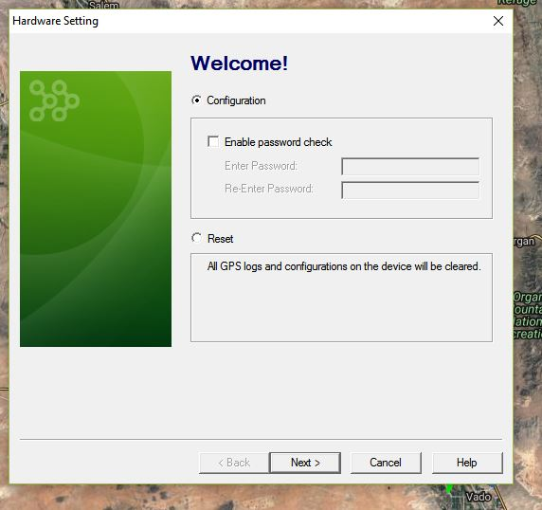

Screen 2 – Utilize this screen to setup manual control (push the button to turn GPS on) or Scheduled control (use the software to schedule the device to turn on at precise times of day, only record data on certain days or during certain times of day). Click next to advance to the manual or scheduled control Screens

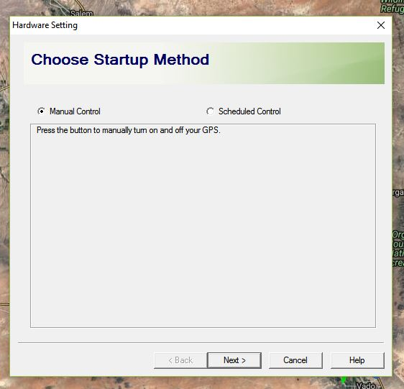

Manual Control Screen – Select your interval between points. Be sure to DESELECT Power Saving mode. Power saving mode puts the device into sleep mode between points and has to reacquire satellite signal for every fix. This results in a reduced fix rate which intern leads to lost data. Smart Tracking mode allows you to put the GPS into sleep mode if the unit is traveling at an increased velocity. For example, it was designed to shut the unit off and save battery when you are driving in a car, as opposed to just walking around. I do not use this feature tracking livestock, however, it could useful if you wanted to exclude data from livestock being trailered, herded, or not at rest.

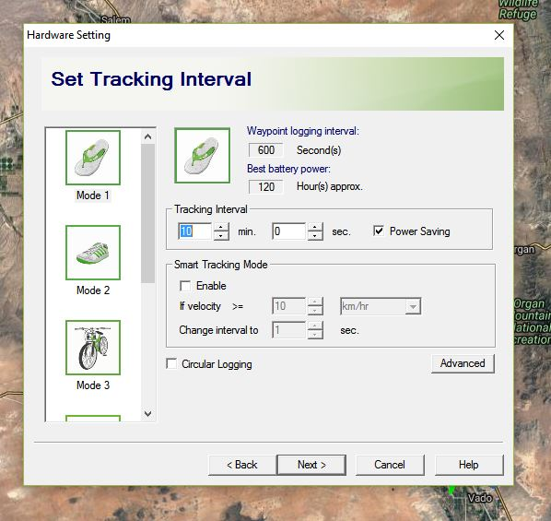

Scheduled Control Screen – Use this screen to schedule on/off times for the device. You could use it to turn on the devices after the collars have been placed on the livestock, or use this mode to only record data during the day/night/morning/noon/evening time. I could see this being useful if you would like to prepare/pack up your GPS tracking collars in the lab so when you arrive at the working facility you only have to place the collars on the animals to save time. Or, this would be useful in a situation like monitoring sheep behavior when animals are herded inside every night and you are only interested in the animals grazing behavior. This data could be sorted in excel later, but it would be a cumbersome task.

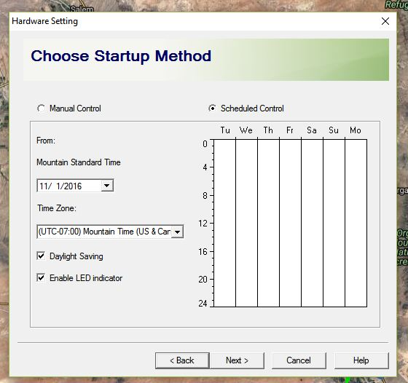

**Chapter 3 – Sorting bad data from Mobile Action i-gotU 120 travel and sports loggers**

This is a reply I received when I contacted Mobile Action to request more information about the data logged by the GPS unit

|  |  |  |
| --- | --- | --- |
| Dear Sir,  Thank you for using ***Mobile Action*** products.  We are sorry, we can only export the data from the GPS device(GT-120), and all the calculations are from the GPS chipset itself, we don't understand how it calculate.  Please see the following information we can only explain.  Please refer to the following steps to get data. 1. Add a new folder in C disk, folder name is GT_DATA_LOG, then run @trip PC program and download trip from i-gotU hardware again. 2. Please run the Microsoft Excel program to open the data file on C:\GT_DATA_LOG, you can see the whole GPS data that we recorded.  ---------------------------------------------------------------- . Date: GPS date  . Time: GPS time, it is local time.  . Latitude: Please refer to wiki website <http://en.wikipedia.org/wiki/Latitude>  . Longitude: Please refer to wiki website <http://en.wikipedia.org/wiki/Longitude>  . Altitude: GPS Altitude, the unit is meter.  . Speed: The unit is meter/hour，This maximum speed of waypoint.  .Type: -1 is POI point，-2 is start point，-4 is end point.  . Distance: The unit is meter.  . Sleep Time: GPS Logger device sleep time. The unit is second.  . EHPE: Estimated Horizontal Position Error: The unit is cm.  --------------------------------------------------------------------------------   Essential:  ‘1’ – the waypoint is displayed on the map ‘ ’ – Blank means waypoint is not displayed on the map. If ‘Optimize track’ is enabled in the setting, waypoint filtered out will not be displayed on the map, and thus the blank (no value).  *Sincerely yours*  Mark Liang | | |
| Mobile Action Service Center also provides customers with easy access to online product [**FAQ**](http://global.mobileaction.com/support/support_Faq.jsp) that contain answers to commonly asked questions. Should you require further assistance, please do not hesitate to contact us via our website [contact us](http://global.mobileaction.com/support/support_Contact.jsp) page within your detail of question and product information please.  ============================== | | |
| **Mobile Action Technology Inc.**  Web URL: [www.mobileaction.com](http://www.mobileaction.com/)  Tel: 886-2-8913-1666 ext 678  Fax: 886-2-8913-1667 | https://ci3.googleusercontent.com/proxy/H4Qj2QN20ipYMazJdzOf1HFy7ZvKAUnBdnyNVC06WzHKdMwtnlXoyT0Q0kguBfQ7iJadlwGq18b3kv66r7cypy7oE-6rVh2fNBVLwkBbSST8fA=s0-d-e1-ft#http://tsdb.mobileaction.com.tw/KMOuterPath/Picture/4552/162 |  |

Step 1 – Open the csv file with raw GPS data

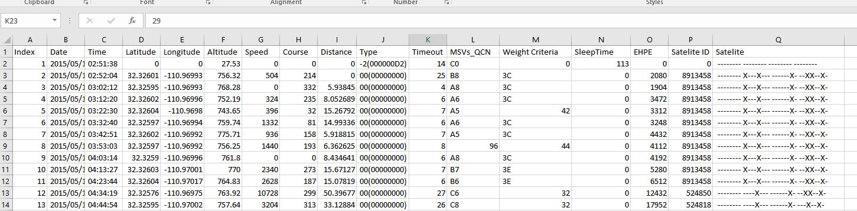

You should have the following columns: Index, Date, Time, Latitude, Longitude, Altitude, Speed, Course, Distance, Type, Timeout, MSVs_QCN, Weight Criteria, Sleep Time, EHPE, Satellite ID and Satellite.

Step 2 – Insert a new column between column A and B, label (cow, animal, bull, lamb etc.) Then add the animal’s ID number to each row. Now combine all animals’ data into this spread sheet (that way you can do the calculations for every animal at once instead of repeating this process for every time.) Leave a blank row between every animal (With this blank row, you can use Ctrl+Shift+the down arrow key to quickly navigate between animals).

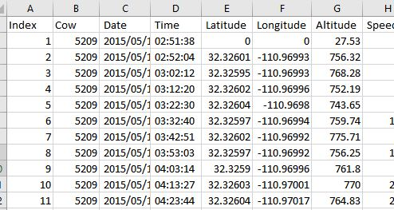

Step 3 – To the left of Column A, add a column, and rename this column, ORDER, and number each row. Be sure to copy and paste this row as numbers. This column allows you to list every cow in order and double check for mistakes when sorting by different columns.

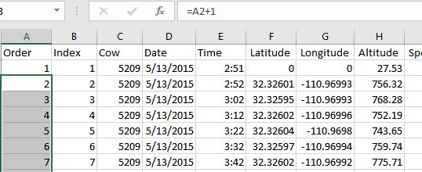

Step 4 - Beside the Date and Time columns add an extra column and name them Date and Time respectively. The original Date and Time columns are in Text format. In the new columns, convert them to values.

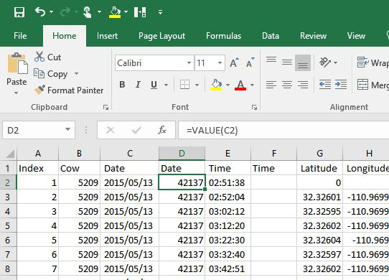

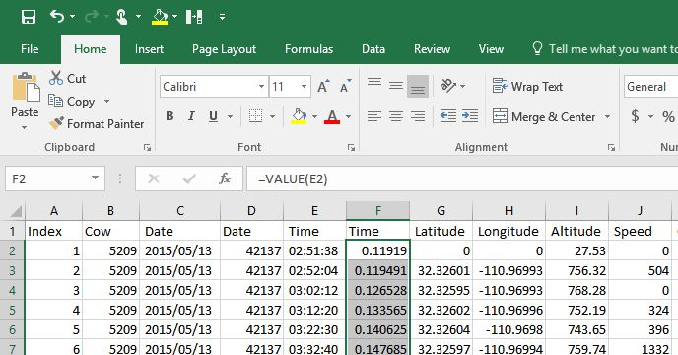

Then format the new Date column to show the date however you prefer and format the time column to military time. Once completed, highlight each column, copy and paste it as numbers to remove the formulas.

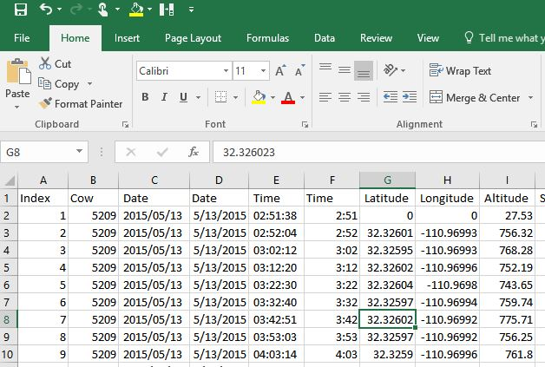

Then delete the “text” Date and Time columns.

Highlight all rows, and use the sort function under the data tab to sort the dataset by date. Remove dates that are not included on the study. Re-sort using the Order column.

Step 5. Insert a column to the right of Time, and label it Time Difference and subtract the previous time to get the time difference between points. *Correction. Use formula

=IF(E3<E2,(E3+1)-E2,E3-E2) to allow for multiple day time differences

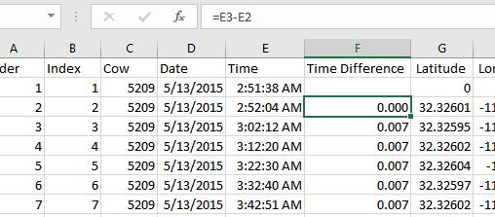

Step 6. Insert a new column to the right of Time Difference and label it Difference in Minutes, and insert the following formula to calculate the difference in time (unit minutes)

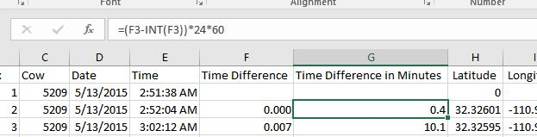

Step 7. Copy and paste both new columns as numbers to remove formulas.

Step 8. Rename column V to “rate” and divide the Distance column by the Time Difference in Minutes column to get rate of travel in meters per minute. Then copy and paste the column as numbers to remove the formulas.

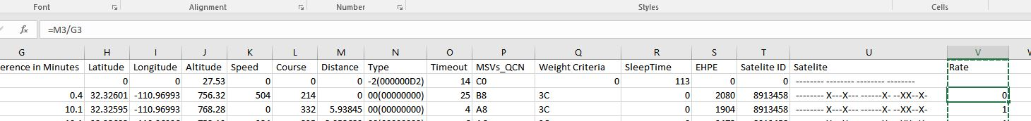

Note from Dr. Jim Sprinkle

*When you save the GPS data as a shapefile in Arcmap, it scrubs the unique numbers for time difference etc. That’s because they need to be saved as text to retain their uniqueness. Here is what I did to correct the problem. I added 3 new time columns to the csv file that I saved as Excel. Two of the columns were identical to your time difference and time difference in minutes column. The other column was a column I called time calc where I copied only the time with your formula =value(cells with text time). There was no need to copy date as a value. After doing my calculations and getting the rate, converting to values, I exported the time difference to Notepad, saved as text, and paste special back into Excel as text. I also had to format that time diff column as text in Excel. When I brought the file into Arcmap and saved as a layer it retained the time difference and date and time points unique characteristics since they are formatted in text. It was very helpful to me when I was deleting points in Arcmap to have unique time values.*

Step 9. To the right of the rate column, create a “rate statement”,

=IF(“rate”>84,1,0)

Copy and paste the column as numbers to remove the formula

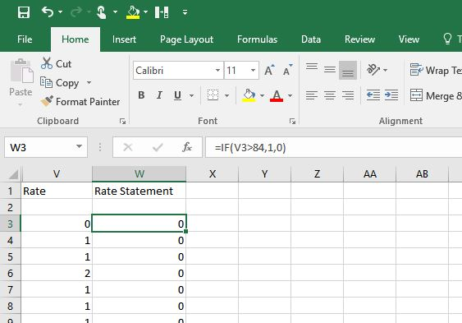

This flags fixes that are traveling greater than 84 meters per minute, the average walking speed of a bovine animal. (If you are working with a different species, you will need to find and substitute in the appropriate velocity).

N. Chapinal, A. M. de Passille, D. M. Weary, M. A. G. von Keyserlingk and J. Rushen. 2009. Using gait score, walking speed, and lying behavior to detect hoof lesions in dairy cows. J. Dairy Sci. 92:4365-4374, Doi:10:3168/jds.2009-2115.

Step 10. To the right of the “course” column add a new column labeled Course Difference, and calculate the difference in course between each fix absolute values using

=ABS(L3-L2)

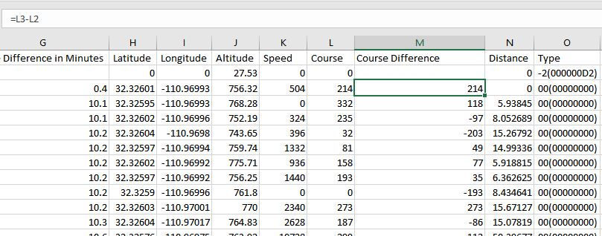

Step 11. To the right of “rate statement” column rename the column to Course Statement, and type in the following statement:

=IF(“course difference” >=100,1,0)

Copy and paste into numbers to eliminate formulas.

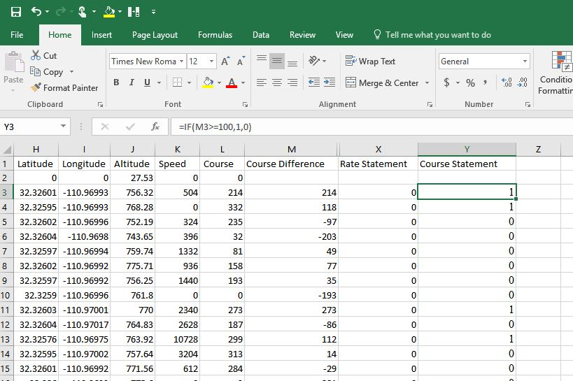

This flags fixes that have drastic course changes. You can see bad positions on the @trip PC google map view, they look like this. However, there is no good way to identify which point that is, or if it is actually good data or the result of a lot of time between fixes.

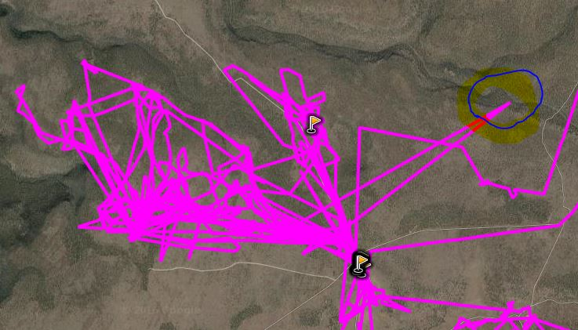

Step 12 - Rename Column Z to “Distance statement”. You now have to determine what distance you would find suspect. In this example, I am tracking a cow at 10 minute intervals. So…

84 m/min * 10 min = 840 meters

Anything greater than 840 meters is suspect, and I want to flag that data

=IF(“distance” >840,1,0)

Be sure to copy and paste as numbers to eliminate formula

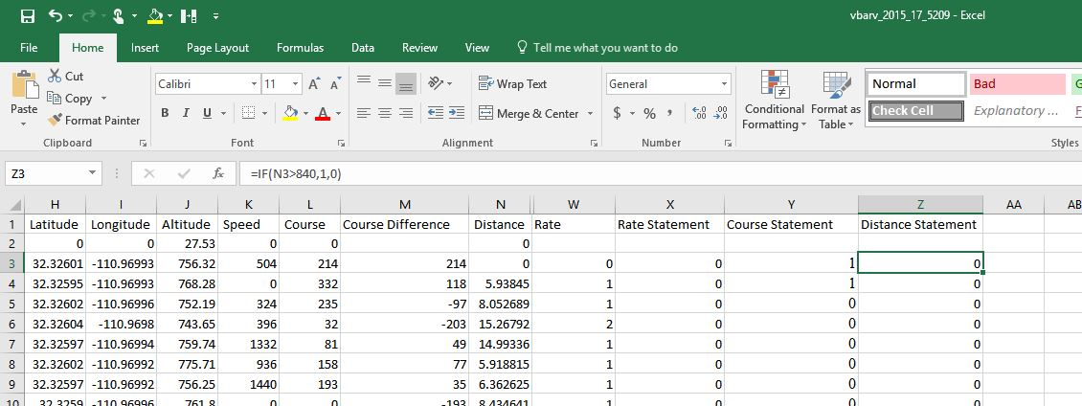

Step 13 – Label column AA, “Total”, and sum the previous 3 columns. Be sure to copy and paste as numbers to eliminate formula.

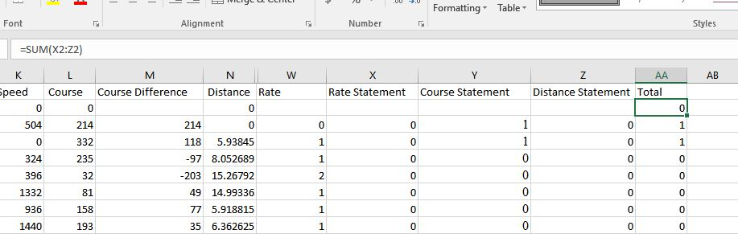

Step 14. Label column AB, “Statement” and utilize the following formula

=IF(“total”>=2,1,0)

This looks at rate, course change, and distance traveled between points and flags them as bad data by finding the points that are way off course as shown previously.

Be sure to copy and paste as numbers to eliminate formula.

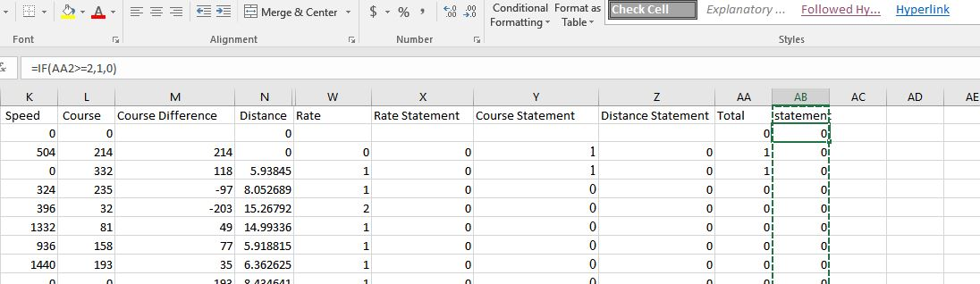

Step 15. Highlight all columns, and under the data tab select Sort, sort by statement. You now have all the data points listed in order. If you would like to double check them to see if they are really bad data, highlight the rows in yellow. Resort by the order column. Then highlight the Statement column and use the Find and Select tool under the Home tab to search for 1s. You can then look at each flagged data point and determine if you think it is good/bad data based on the animals speed, distance traveled between points, and time between points. In the interest of time on large data sets, I would simply eliminate all flagged data. Later data analysis will make up for distance traveled.

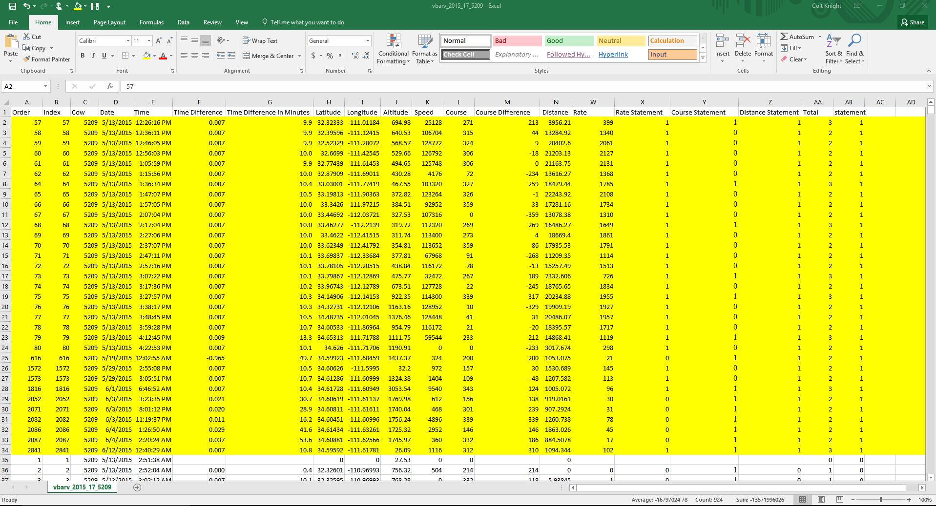

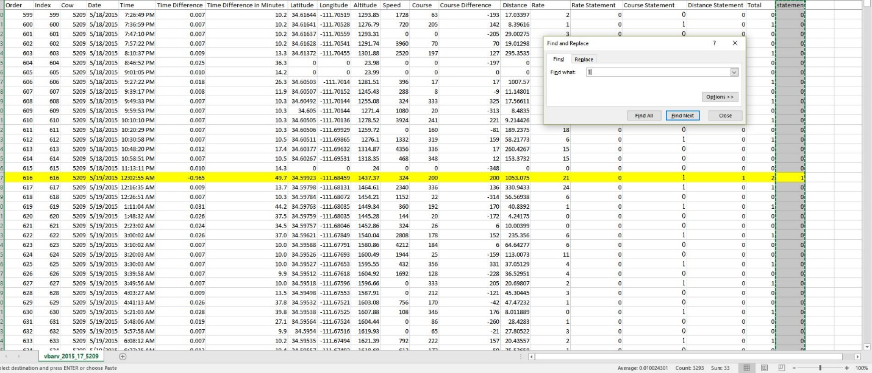

Step 16. Save data with appropriate file name so that you can tell the difference between raw and clean data.

Additional data cleanup- In most cases, the above calculations will clean up most of the bad data. However, in some circumstances, not all bad data has been removed. Typically, you will see high estimates for distance traveled or strange elevation/altitude measurements. Also, you may see points on ArcMap that are clearly out of boundaries for cattle to utilize.

One method is to order your spreadsheet based on distance traveled, rate, or altitude to find suspect points. Additionally, you could use the ArcMap to find and remove obviously bad data points (points outside of the acceptable boundaries.)

*I am including a few notes from Dr. Jim Sprinkle on his additional data cleanup*

*I deleted points from the raw csv file by finding those points with altitudes that were way off. For my data set, it was altitude <1400 and >1900 meters. This let me eliminate about 50 or 60 data points over 30 days (taken every 5 minutes).*

*I added an extra step in data cleanup. I cleaned up the GPS shape file in Arcmap with the edit function. The way I did this was to overlay the points over the World Imagery file I downloaded from Esri. With this file, I was able to eliminate waypoints that were clearly outside the pasture boundaries. After doing this, I went through each day’s data and eliminated waypoints that bounced outside the normal travel rate. I did this by the Selection/Select by Attributes menu function. I chose Date = Get Unique Value and chose the date. I then looked at the highlighted points and with the identify function was able to identify when the respective point was recorded along with its values. Often, there were two points close together in time as they bounced off the path. Using the edit function, I then highlighted the point I wanted to delete. You do have to make sure to only have one point showing up in blue when you select it to delete or you will delete the entire day. After getting rid of the bad waypoints I saved the file, then cleared selected features and chose the next day for evaluation.*

*After cleaning up the file in Arcmap, I exported the cleaned up file using the Conversion Tools\Excel\Table to Excel function when the layer was selected. This new file became the file that I used for the Pivot Table summary to prepare my SAS file.*

*I added one more calculation to my final Excel file. I added a column called “15 Slope” that was populated with =IF(N2 > 15, 1, “”) . This allowed me to call up the sum of 15 slope in the pivot table for each day. I then divided this number by the GPS count for each day and multiplied by 100 to get the percentage of time the cows accessed slopes greater than 15%.*

The above calculation could prove extremely useful, and the methodology could apply to any number of calculations, such as high/low elevation usage, time spent traveling throughout the day, etc.

**Chapter 4 – Converting Longitude and Latitude to UTM (Northing and Easting)**

To be able to estimate distance traveled for livestock, we need to calculate the distance between two points which we can do easily using Pythagoras’s theorem if we have positions in UTM (Northing and Easting). In addition, to utilize Arc Map more accurately, using UTMs instead of Longitude and Latitude will result in less error because ArcMap will not have to convert between extreme units like minutes and degrees to meters.

You can easily batch convert Longitude and Latitude to UTM using a spread sheet provided by University of Wisconsin located here

<https://www.google.com/url?sa=t&rct=j&q=&esrc=s&source=web&cd=4&ved=0ahUKEwiasvuwy4jQAhWmwVQKHT2YDc8QFggwMAM&url=http%3A%2F%2Fwww.uwgb.edu%2Fdutchs%2FUsefulData%2FUTMConversions1.xls&usg=AFQjCNE5gDT3aToy0F3g1A4vGIiKamHc6g&sig2=0aoZK6A-4qIYEAio5ae2QQ&cad=rja>

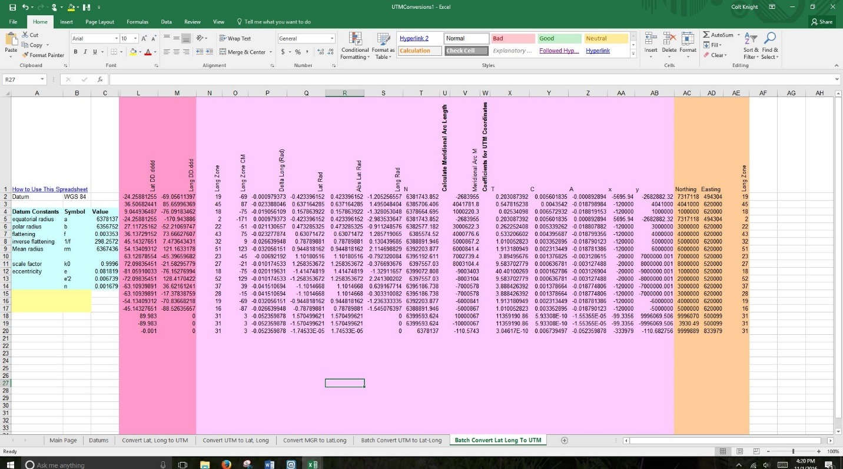

Open the spreadsheet and select Batch Convert Lat Long to UTM

Paste your Latitude and Longitude coordinates into L2 and M2 cells.

Be sure to highlight the row N2:AE2 and copy the formulas all the way down through the example formulas, and then again till the end of your dataset.

Take note of Column AE (You will need this number later to import your data into ArcMap)

Copy and Paste as values the Northing and Easting columns next to the Longitude and Latitude columns in your data spread sheet.

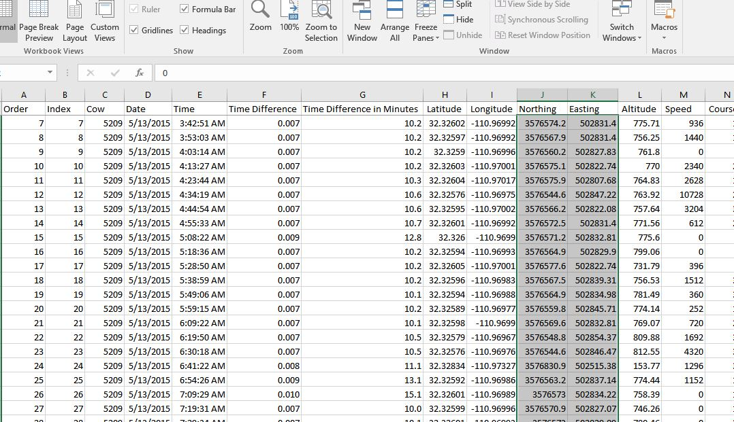

**Chapter 5 – Estimating Distance traveled**

Now add a distance traveled column and utilize this formula to calculate the distance traveled in meters between points:

Northing 1=" N1" Easting 1="E1" Northing 2="N2" Easting 2="E2"

=SQRT((N2-N1) ^2+(E2-E1) ^2)

Select the cow number in the first column and press Ctrl+Shift+down arrow, and this will take you to the next cow in your list. Clear the contents in the blank space between each cow and the first row for Distance Travelled. Since we performed the formula for distance travelled for all animals, the first distance travelled measure for each cow is actually the distance between where the previous cow finished the study and next cow started the study, so we need to clear the contents of those cells.

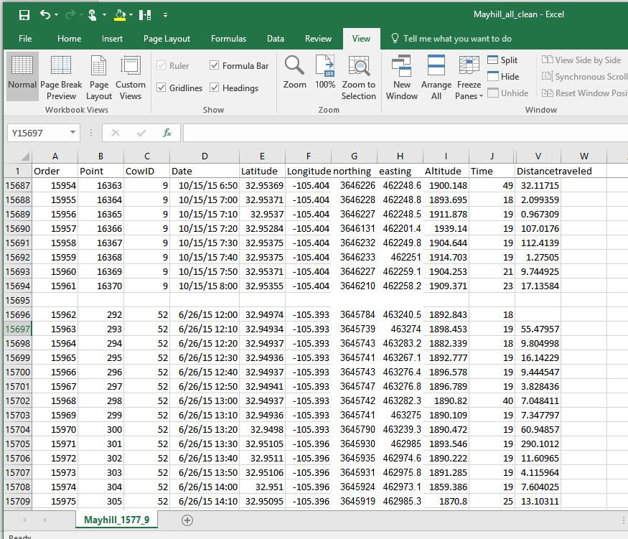

**Chapter 6 – Generating Accurate Elevation measurements**

Step 1 – Format spreadsheet for importation into ArcMap. Remove all spaces and symbols in column headings. Utilize underscores if needed. Save as a .CSV file.

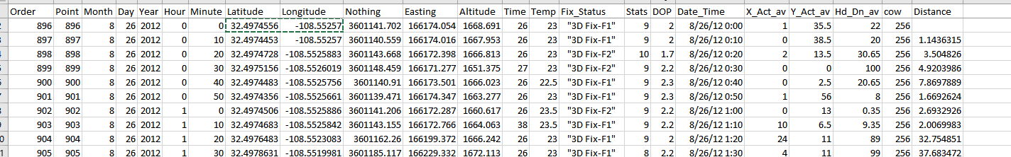

To avoid any trouble importing files into ArcMap, create a new folder directly on your c drive and name it ARC. I use subfolders within ARC to separate locations/ranches. (Once you have several studies on your computer, the files become confusing without good organization.)

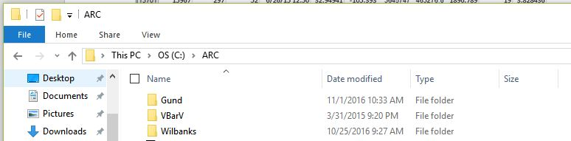

Step 2. Find a Seamless DEM

Go to

<https://viewer.nationalmap.gov/basic/>

Select Elevation Products (3DEP), search availability and select the finest resolution

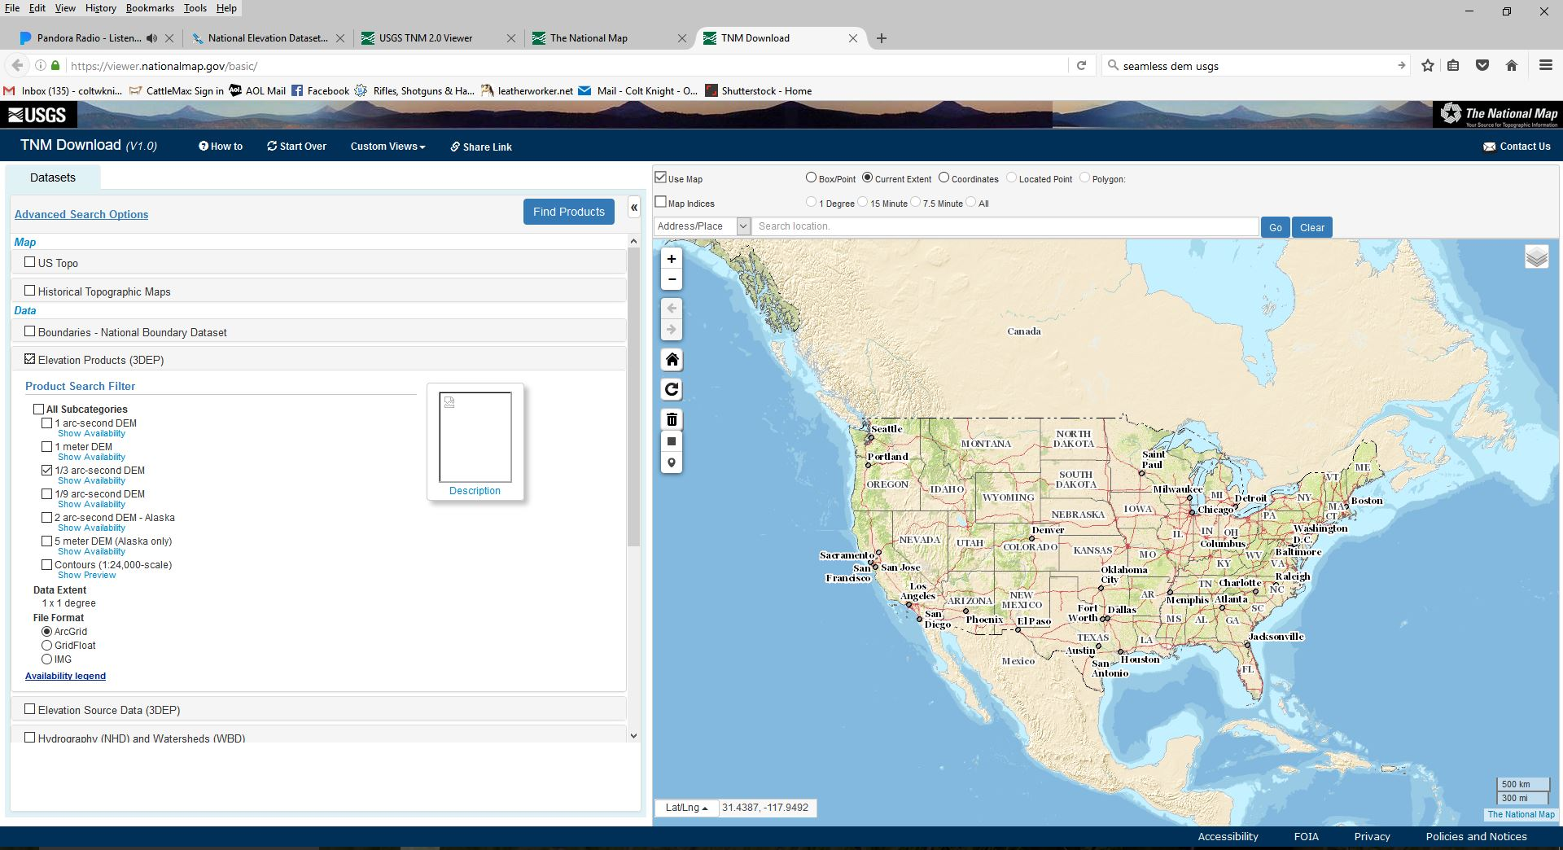

Zoom in on the location using the map to the right, and select the area you need for your study. If you are unfamiliar with the location, you can use your data set and Google Earth to find the spatial location of the ranch.

Go to your spread sheet and pick a longitude and latitude from the data set

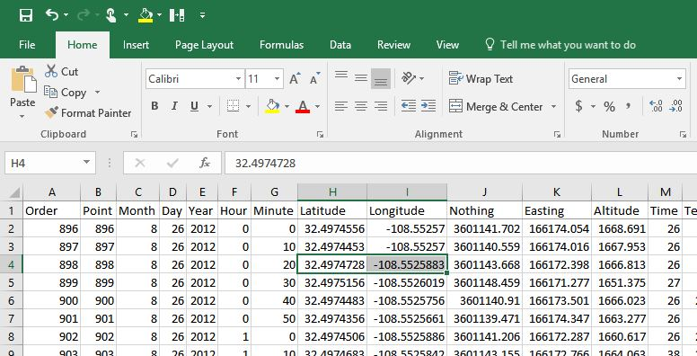

Search for that location on Google Earth

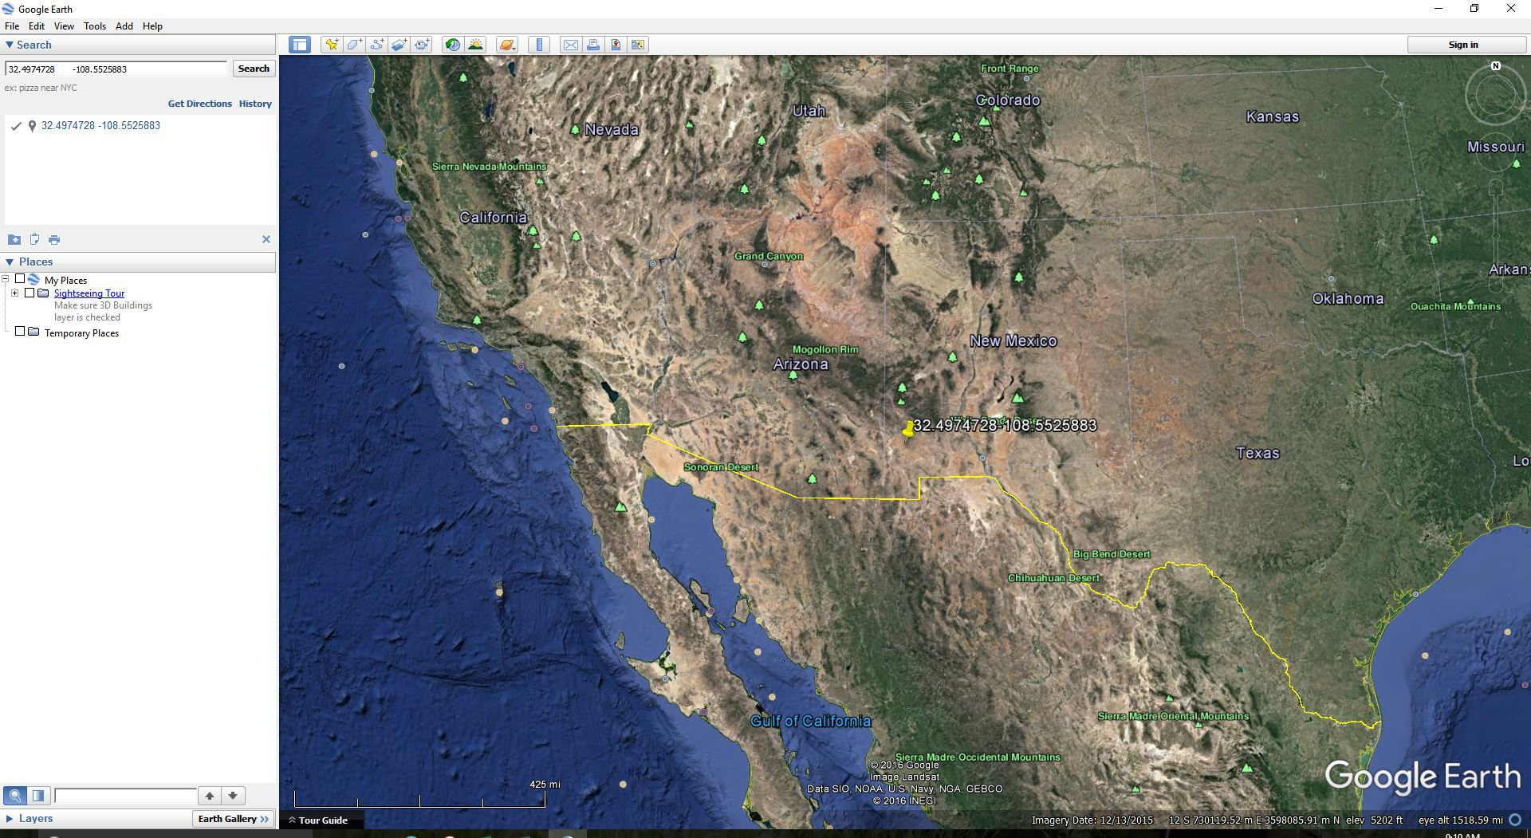

You now have a pinpoint location of the ranch, and you can use this as a reference to find the DEM map on The National Map from the USGS.

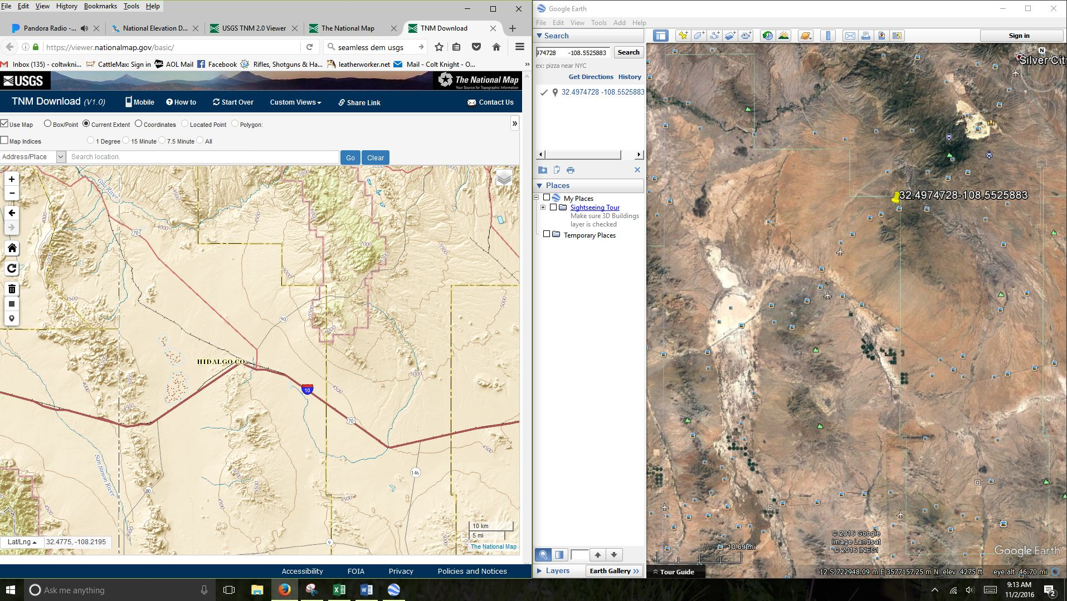

Use the square button selection tool to highlight the area surrounding the ranch

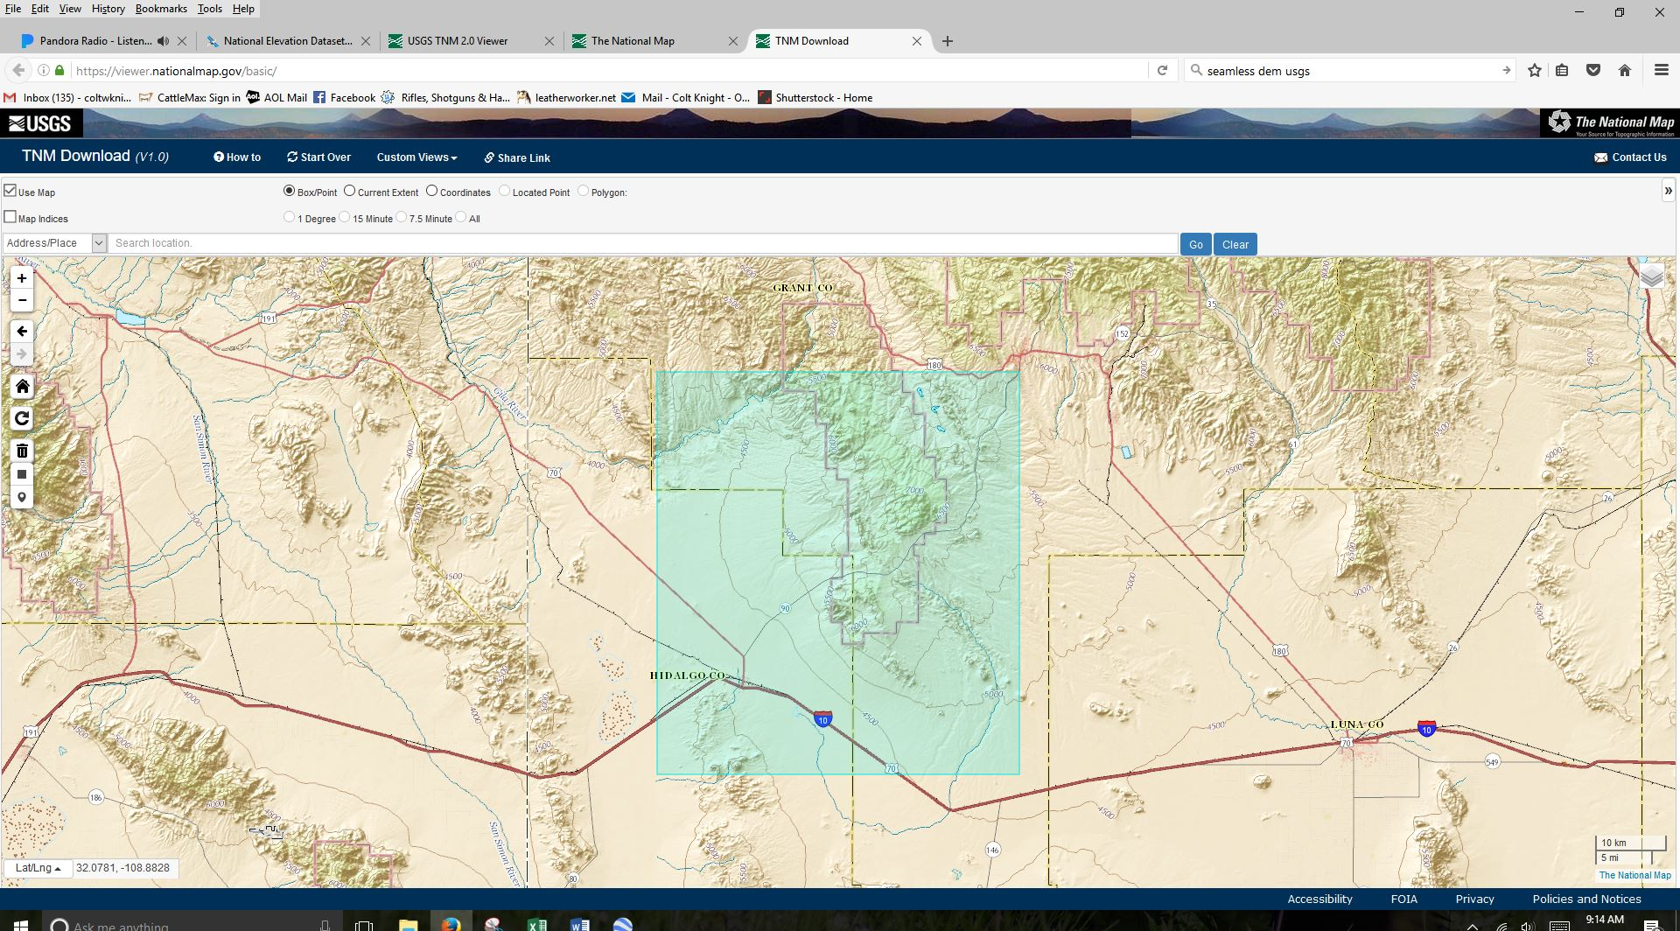

Then click the find products button

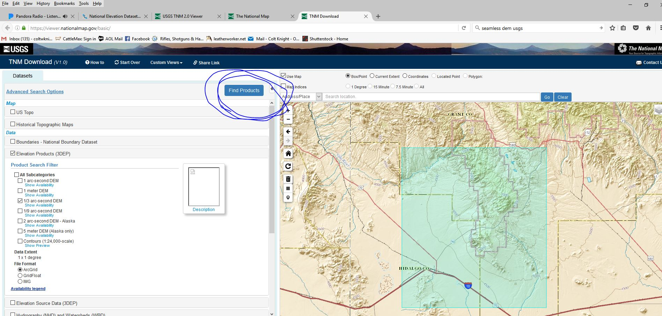

The next screen will then generate an elevation map, add it to your cart

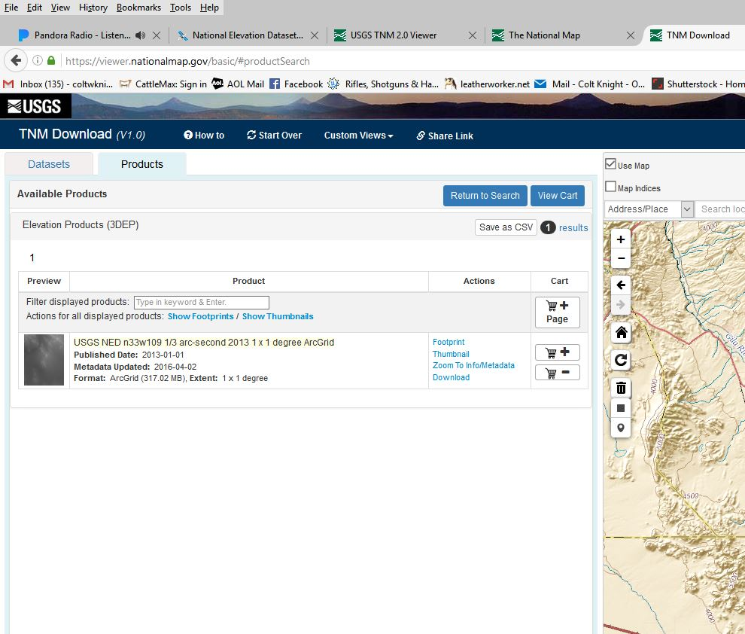

Then view your cart, and download the data

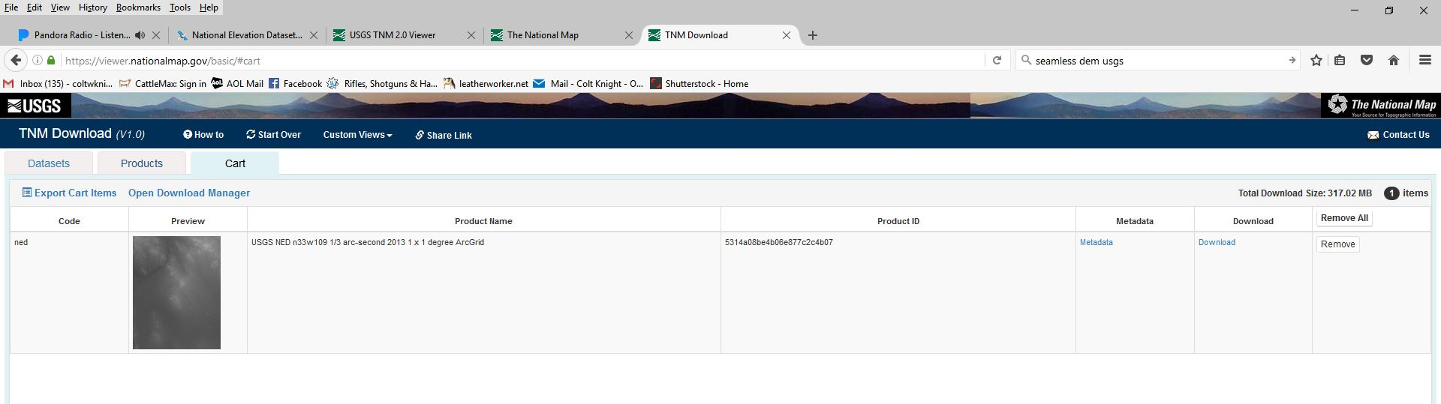

Extract and save all the files contained in the download to your C drive, ARC folder, and ranch sub folder

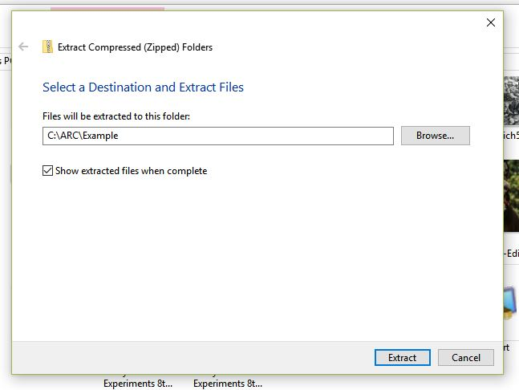

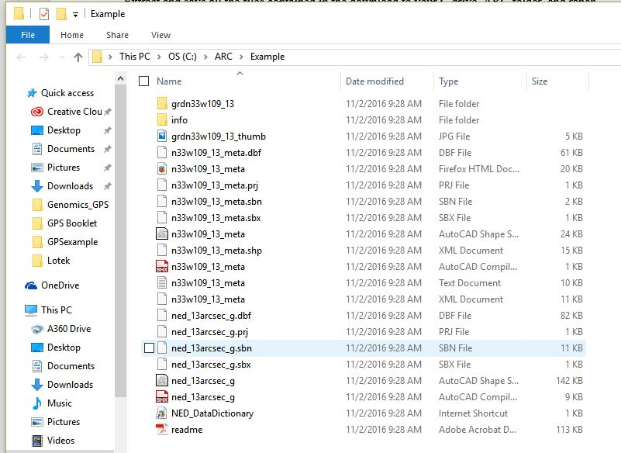

Open ArcMap, and create a new blank map

Under File, click Add Data and select Add XY data

Select the CSV spread sheet you created earlier

Set X to Easting

Set Y to Northing

Leave Z blank

Then click EDIT, under Projected Coordinate system, Select UTM, then select NAD 1983, and finally, select the appropriate UTM zone. In this example, which is in New Mexico, 12N is the appropriate zone. If you are unsure which zone, utilize the batch convert long lat to UTM spreadsheet from the University of Wisconsin to identify the zone you will need. Click OK

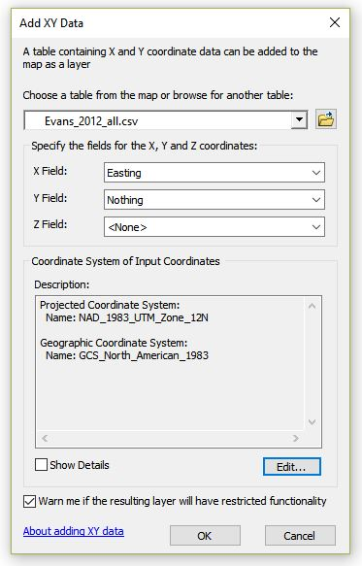

Now the CSV has been added to ArcMap, but it needs to be converted to a shape file to be useful.

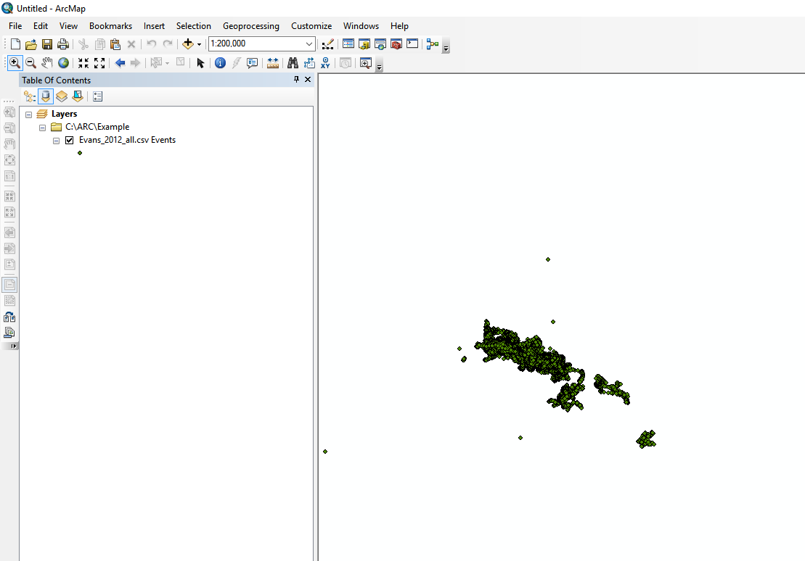

Right click the csv file, click data, click export data, and save the file in the appropriate location with a name you can easily recognize

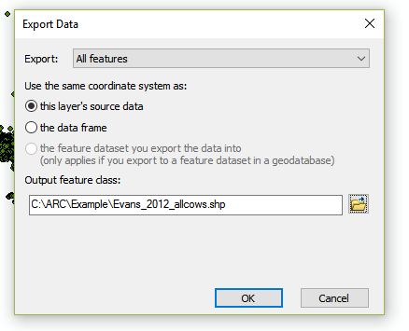

Once the shape file has been added to the map, you can remove the CSV to reduce clutter.

Then click the add data button and upload the DEM map from National Maps

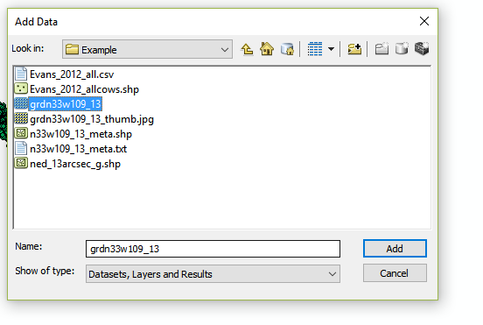

Here is an example of cow data (cleancoltcollars) plotted against the elevation map in ArcMap

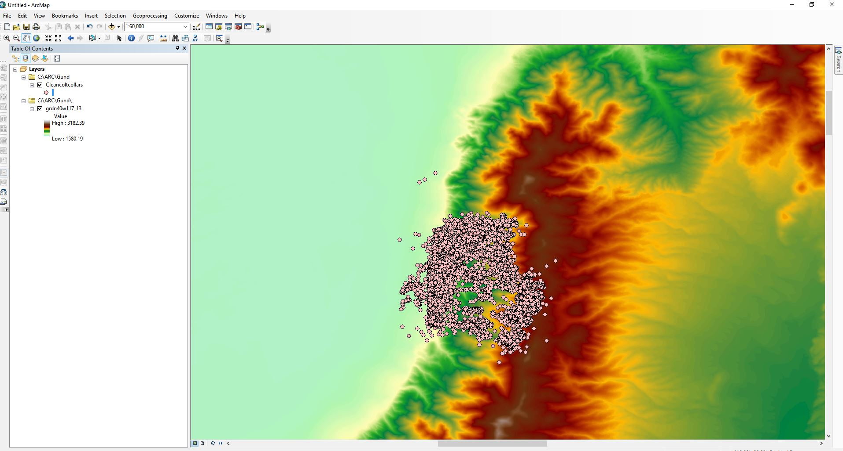

Once the shape files and DEM map are in place, elevation can be extracted for all points and all animals at once.

Step 1. Create a new folder within the Ranch and ARC folders named Extraction

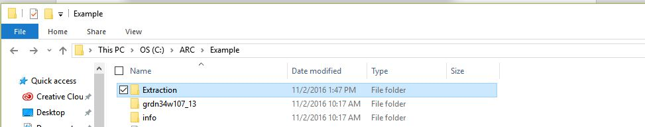

Step 2. Open Arc Tool Box > Spatial Analyst Tools > Extraction>Extract Values to Points

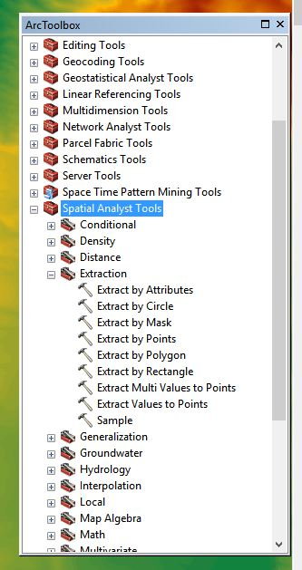

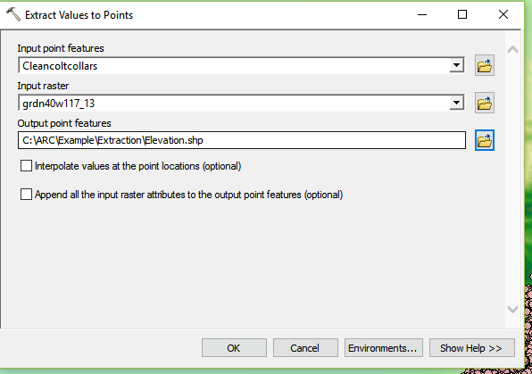

Input Point Features – animal shape file

Input Raster – Elevation file

Output Point features – name this file “Elevation” in the newly created extraction folder

Click >Environments> Processing Extent> change default to Same As Display (make sure you zoom in and include all points on your map) then press OK

You have now generated elevation values for your points.

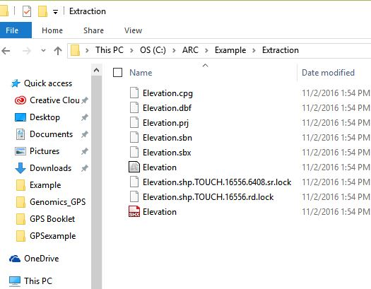

Open the “Elevation.dbf” file in Excel – The column labeled RASTERVALU is elevation values in meters. Simply copy this column and paste it into your data spreadsheet. Rename the column elevation.

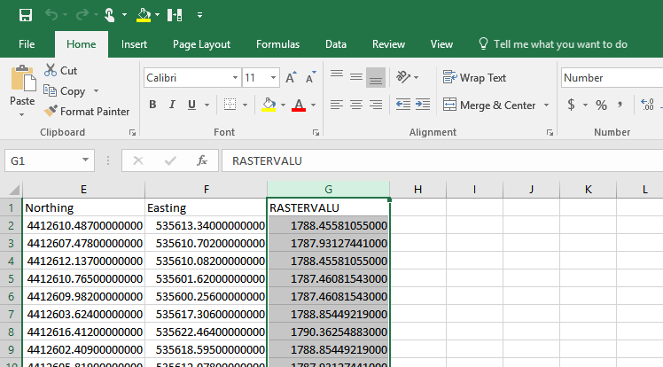

**Chapter 7 – Generating Slope utilization data**

Once the animal shape file and elevation files are in place on ArcMap, generating slope data is relatively easy.

Step 1. Open Arc Toolbox>Spatial Analyst Tools>Surface>Slope

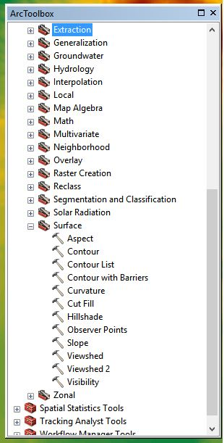

Input Raster = elevation map

Output Raster – name the file “Slope” in the ranch folder

Click Environment>Processing Extent>change default to same as display (make sure your map is zoomed in on your points and includes all points).

Change output measure to percent-rise

Leave Z-factor as it is

Press OK

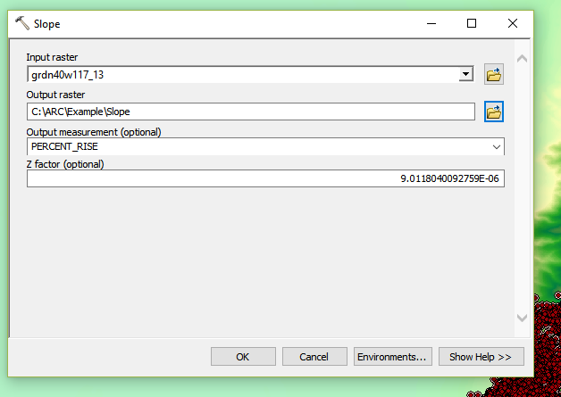

A slope file has now been generated

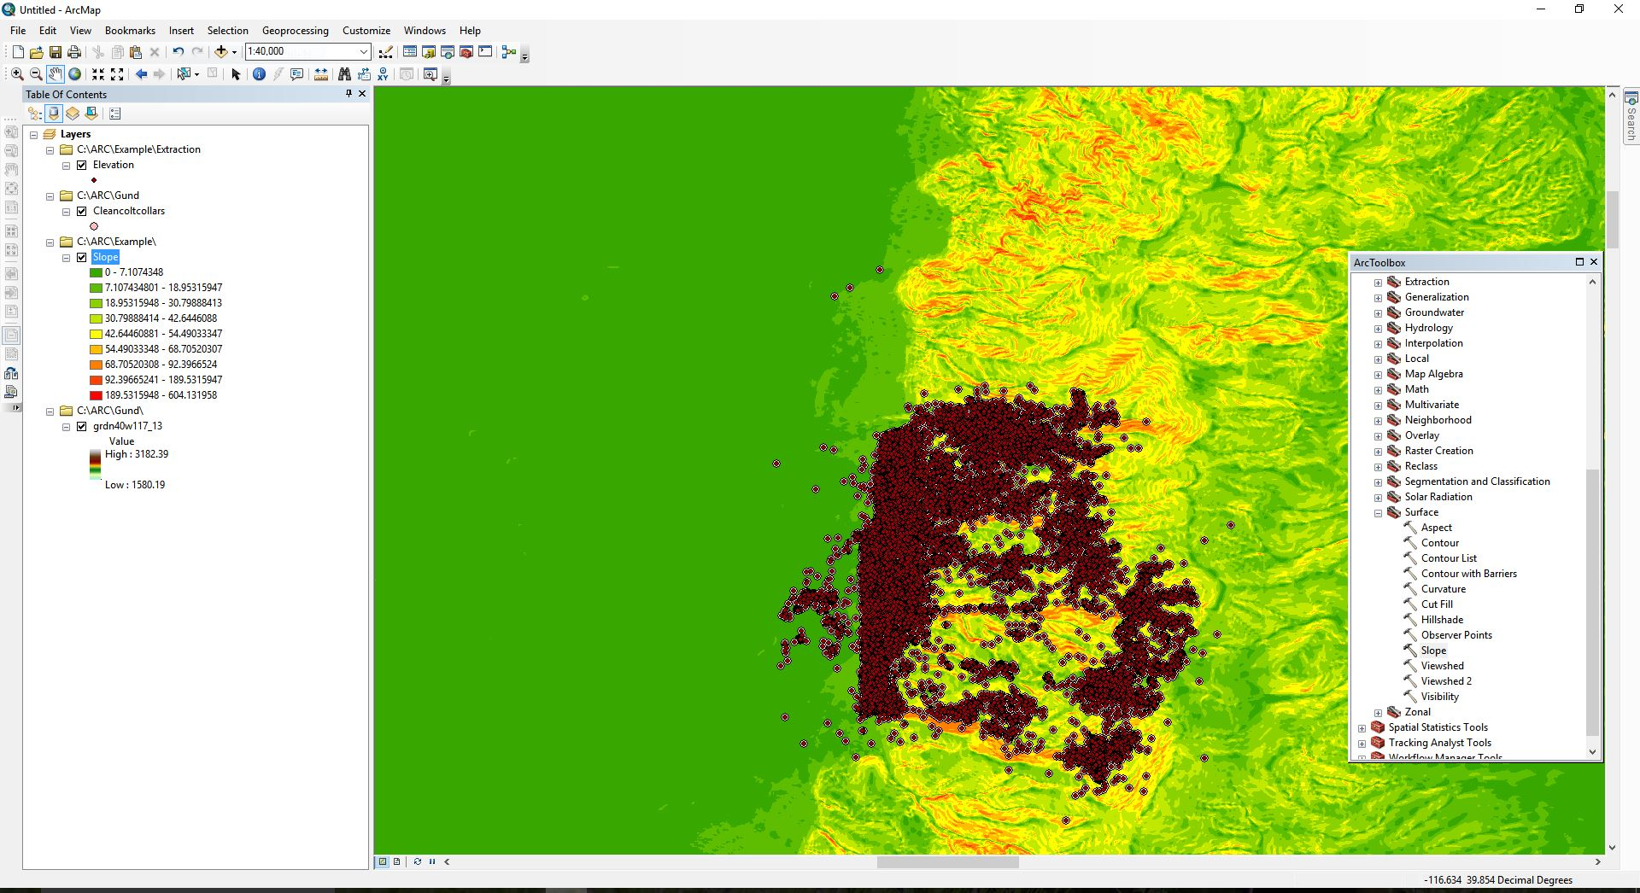

Open Arc Toolbox>Spatial Analyst>Extraction>Extract Values to Points

Input Point features = animal shape file

Input Raster = slope file

Save the file as “Slope” in the extraction folder

Click Environments>Processing Extent and change default to Same As Display

Press Ok

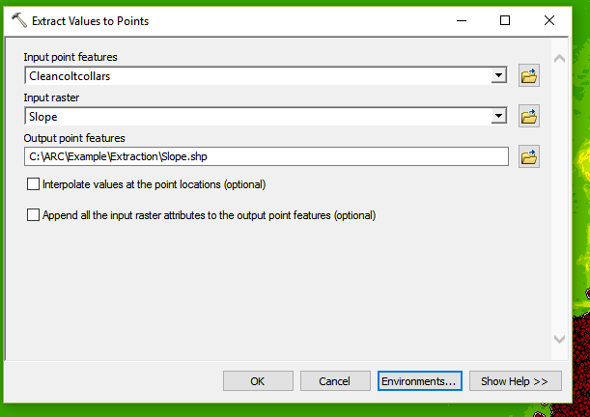

The slope files have now been generated. Open the “Slope.dbf” file in Excel – The column labeled RASTERVALU is slope values in percent rise. Simply copy this column and paste it into your data spreadsheet. Rename the column slope.

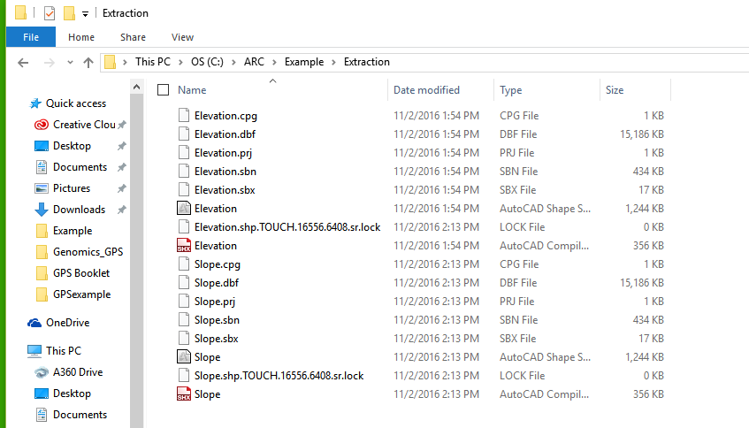

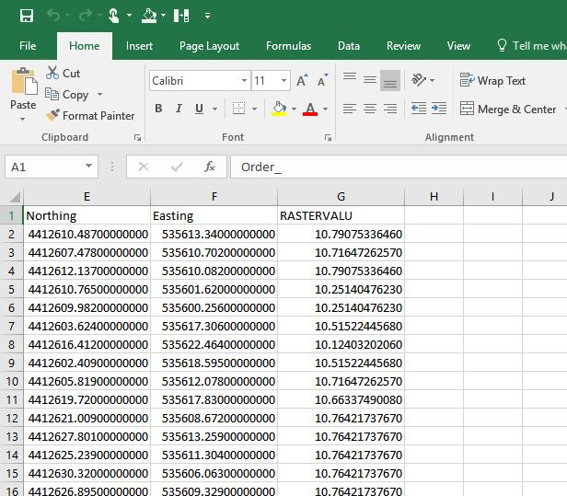

**Chapter 8 – Generating Distance from Water measurements**

Understanding animals’ interaction with water, especially on arid rangelands, is important information for researchers. With the aid of Google Earth, ArcMap, and Excel, numerous inferences can be made with regards to animals’ interaction with water. First, we can calculate how far an animal is from water for every GPS position. We can estimate how much time they spend close to water, and how far they travel from water. We can even determine how often an animal visits a water source. This tool also allows you to map out distances from supplement sources, riparian areas, barns, trails, etc.

Step 1. Import a shape file of water sources from the ranch onto the ArcMap with the ranch borders, animals, elevation, and slope already open. If you do not have a shape file of water allotments, you can generate one easily using Google Earth, Excel, and ArcMap. See below

Step 2. Open Google Earth. Use a Longitude and Latitude point form your spreadsheet to locate the ranch. Search Google Earth for the known water sources. In this example, I have zoomed in on a stock tank/pond. Under the tools tab>Options>3D View make sure to select Universal Transverse Mercator under Show Lat/Long>OK

Now hover the cursor over the stock tank and write down the Northing and Easting points in the lower right hand corner.

­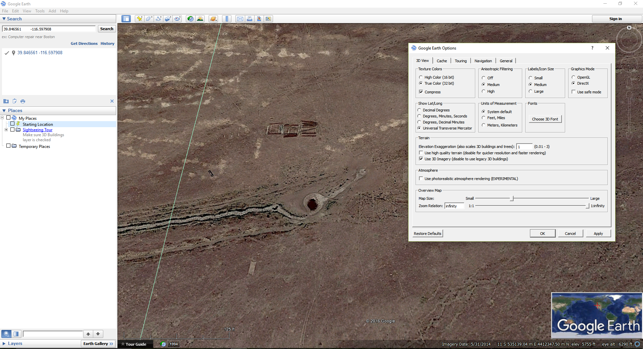

Create a short Microsoft excel file with these coordinates and save as a CSV file

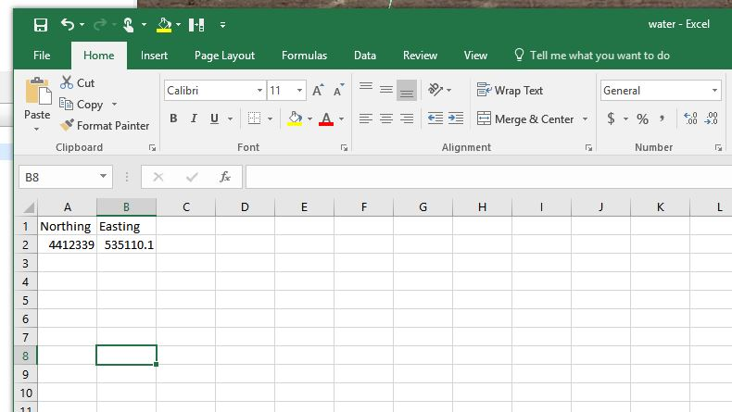

Import this into ArcMap File>Add Data>add XY data

X = easting

Y = northing

Z = default

Then click EDIT, under Projected Coordinate system, Select UTM, then select NAD 1983, and finally, select the appropriate UTM zone. In this example, which is in Nevada, 11N is the appropriate zone. If you are unsure which zone, utilize the batch convert long lat to UTM spreadsheet from the University of Wisconsin to identify the zone you will need. Click OK

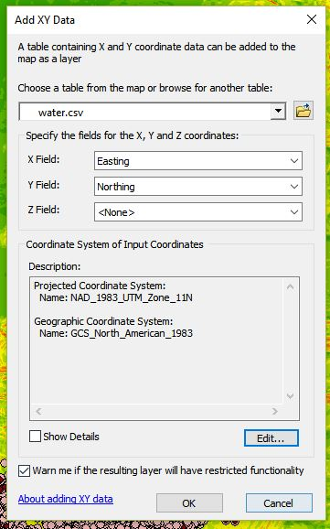

Once the data has been added to ArcMap, right click the water.csv file, Data>Export Data save it as a shape file named water

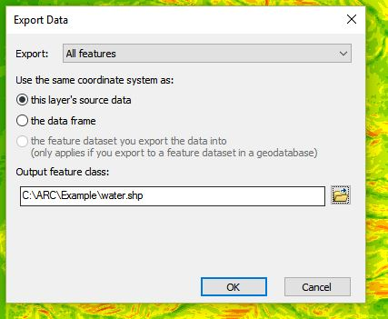

Once the water shape file has been added, remove the csv file

Open Arc Toolbox>Spatial Analyst Tools>Distance>Euclidean Distance

Input raster = water shape file

Output distance raster = save as “distwater” in the ranch folder

Output cell size = 5-10 meters

Environments>Processing Extent> change default to same as display

OK

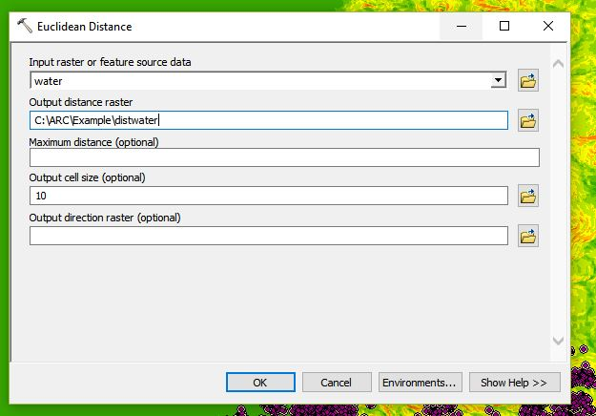

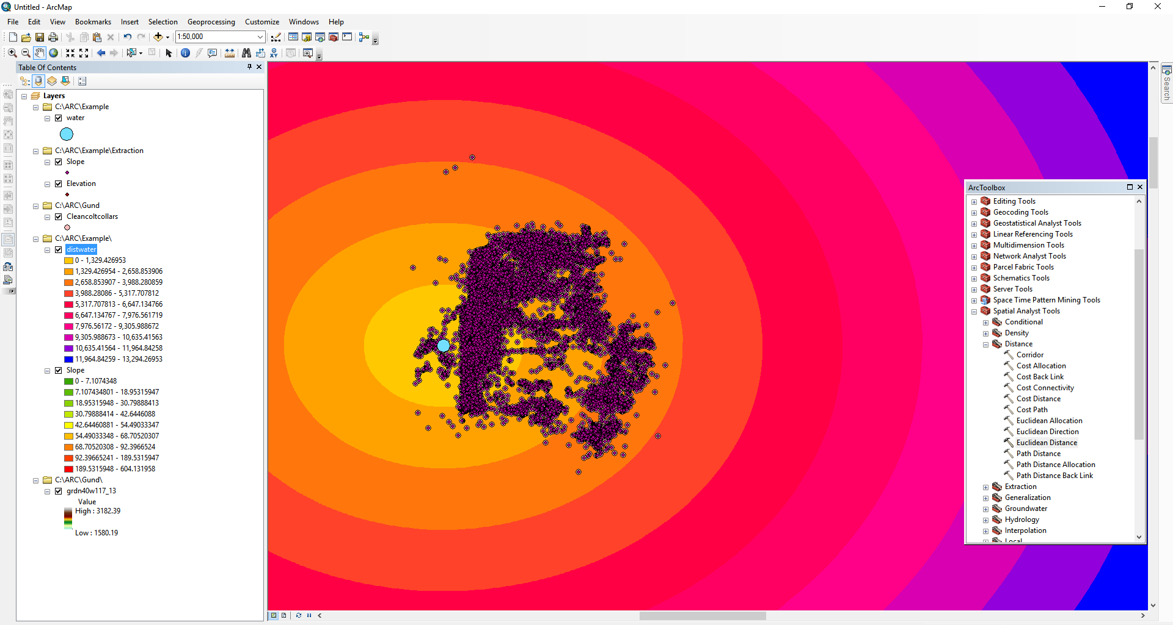

Now the data must be extracted like Elevation and Slope

Go to Arc Toolbox>Spatial Analyst Tools>Extraction>Extract Values To Points

Input point features = animal shape file

Input raster = distwater file

Save it to the extraction folder as “dist2water”

Environments>Processing Extent>change default to same as display

OK

The dist2water files have now been generated. Open the “dist2water.dbf” file in Excel – The column labeled RASTERVALU is distance to water values in meters. Simply copy this column and paste it into your data spreadsheet. Rename the column dist2water.

**Chapter 9 – Utilize Pivot Tables in Excel to easily calculate Means, Mins, Max, and Counts.**

Tracking data spreadsheets can often exceed 100s of thousands of rows with countless columns. Interpreting this data becomes increasingly cumbersome when you cannot simply scroll through data. Using pivot tables in Excel easily allows researchers to orientate data in an easy to use fashion or make tables of averaged data to run through statistical programs.

The use of pivot tables is virtually limitless, so I will only go through some basic tracking uses

For those unfamiliar with Pivot Tables, a basic Microsoft Office primer can be found here:

https://support.office.com/en-us/article/Create-a-PivotTable-to-analyze-worksheet-data-a9a84538-bfe9-40a9-a8e9-f99134456576?ui=en-US&rs=en-US&ad=US

Here is a relatively small GPS dataset with 45796 observations

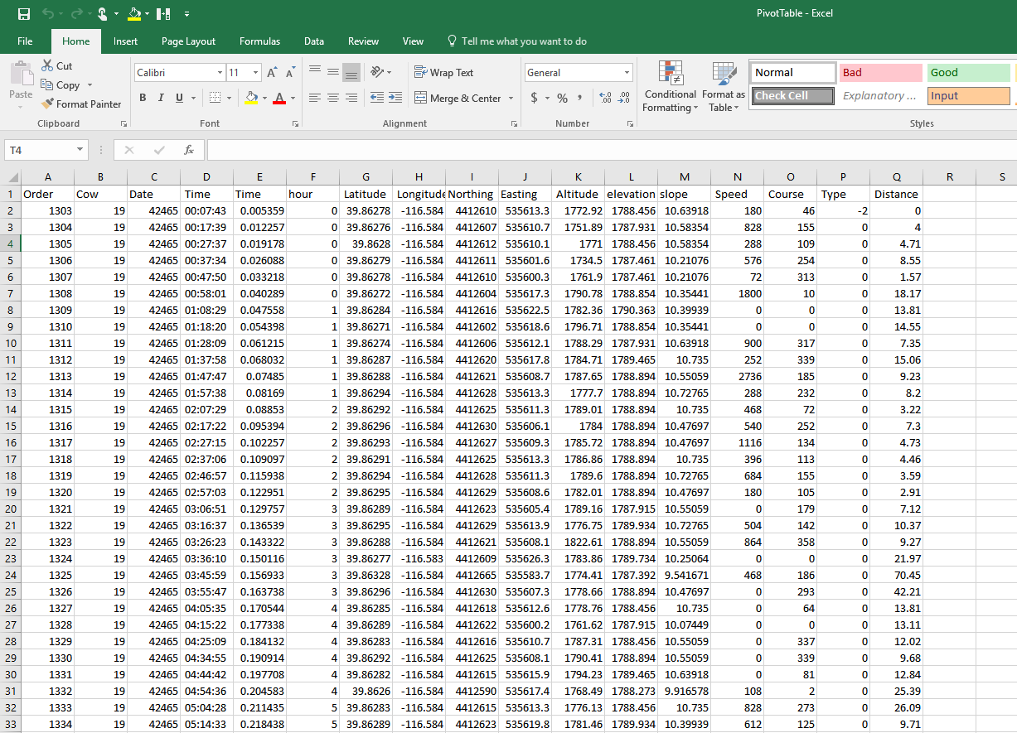

I am going to highlight the dataset, select the insert tab and press insert Pivot Table

First, I want to check my fix rate

Row = cow, Column = date, values = count of northing

This quickly allows me to see how many positions each collar/cow had each day. In this circumstance, I took a position every 10 minutes, so a perfect fix rate would be 144 per day. I can divide the actual positions by 144 and get the fix rate for each cow for each day

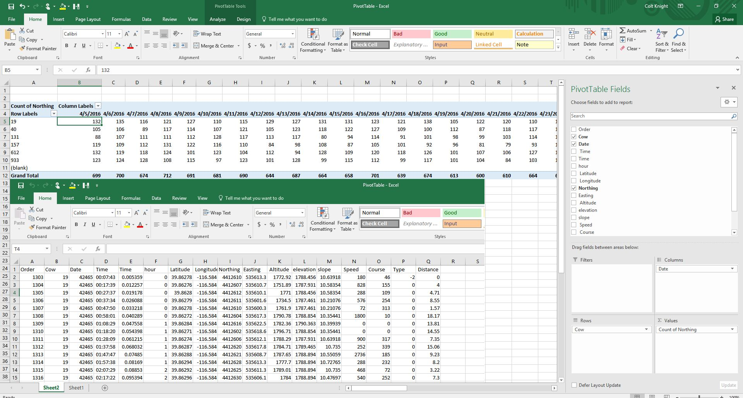

Next I want to know how far an animal traveled each day

Row = cow, Column = date, values = Sum of Distance

Average elevation utilization

Row = cow, Column = date, values = average elevation

Min elevation

Row = cow, Column = date, values = Min elevation

Max elevation

Row = cow, Column = date, values = Max Elevation

These can be repeated for Slope and Distance from Water

Once you have all the information you need, copy and paste the pivot table as numbers, label the rows and columns properly and save as a .csv for importation into SAS.

You can also utilize If statements

For example, you want to estimate how much time is spent by water. Add a column besides the Dist2water column =IF(“dist2water cell” <200,1,0) excel will flag every point where the cow was within 200 meters of water and mark it with a number 1, and any time the animal was further than 200 meters away, a number zero. Use the pivot table to quickly average that column per animal per day, and it will give you a percent of time spent by water. You can do the same for elevation or slope. For example, percentage of time spent in high or low elevation, or time spent on/off challenging slopes.

If you would like to look at what happens throughout the day you can set the time column to military time and add 3 more columns beside time labeled Hour Minute and Second.

=Hour(“time cell”) will pull out the hour. You can then use the pivot table to summarize the animal’s activity throughout the day, every day for all animals.